Dewlap color variation in *Anolis sagrei* is maintained between habitats within islands of the West Indies

*Raphaël Scherrer,[1] Colin M. Donihue ${}^{1,4}$,  
R. Graham Reynolds ${}^{2}$, Jonathan B. Losos ${}^{1,4}$ and Anthony J. Geneva ${}^{1,5}$ ${}^{1}$
 Department of Organismic and Evolutionary Biology and Museum of Comparative Zoology  
Harvard University, Cambridge, MA, USA ${}^{2}$ 
 Department of Biology, University of North Carolina Asheville, Asheville, NC, USA ${}^{3}$ 
 Current address: Groningen Institute for Evolutionary Life Sciences,  
Groningen, The Netherlands ${}^{4}$ 
 Current address: Department of Biology, Washington University, St. Louis, MO, USA ${}^{5}$ 
 Current address: Department of Biology, Center for Computational and Integrative Biology,  
Rutgers University–Camden, Camden, NJ, USA*

***Abstract****. Animal signals evolve in an ecological context. Moreover, locally adapting animal sexual signals can be especially important for initiating or reinforcing reproductive isolation during the early stages of speciation. Dewlap color in* Anolis *lizards can be highly variable between populations in relation to both biotic and abiotic adaptive drivers, albeit at relatively large geographical scales. Here, we investigated local adaptation of the dewlap across habitat-types at a small spatial scale, as this may give an indication of how conditions for the early stages of speciation may be met. We explored variation in dewlap coloration in the most widespread species of anole,* Anolis sagrei*, across three characteristic habitats spanning the Bahamas and the Cayman Islands. Using reflectance spectrometry as well as supervised machine learning, we found significant differences in spectral properties of the dewlap between habitats within small islands. Passive divergence in dewlap phenotype associated with isolation-by-distance did not explain our results. Instead, the observed patterns in dewlap coloration are more consistent with an adaptive explanation in these* A. sagrei *populations, as one would otherwise expect differences within islands to be erased by gene flow at such small geographical scales. These habitat-specific dewlap differences varied in magnitude and direction across islands, and may suggest a role of sexual selection in driving these local patterns. While at present, populations from these different habitats probably experience too much gene flow to follow distinct evolutionary lineages, should additional barriers arise between habitat-specific populations, the observed disruptive selection on dewlap coloration may facilitate ecological speciation.*

**Keywords** — *Anolis*, reflectance, local adaptation, sexual signal, supervised machine learning

# Introduction

The staggering diversity of animal communication signals has long been of interest to evolutionary biologists. Animals use chemical, mechanical, electromagnetic, and visual signals to communicate in a wide variety of contexts, including, for example, competition for mates, species recognition, aposematism, and cooperation (Bradbury & Vehrencamp, 2011). A primary evolutionary factor shaping communication signals is the sensory system and behavior of their recipient(s) (the sensory drive hypothesis; Endler & McLellan (1988; Endler, 1992, 1998)). Over the past decades, scientists have established that signals evolve in an ecological context and are dependent on environmental conditions (Endler, 1992, 1993b; a). Just as different habitats may favor different combinations of eco-morphological traits to maximize performance and fitness (Arnold, 1983), they may also shape different forms of a signal, so as to maximize its transmission and detection (e.g. Seehausen (1997)), or reduce its detection by unintended recipients such as predators (Endler, 1984, 1990, 1991; Halfwerk *et al.*, 2014). This selective pressure may drive the local adaptation of communication signals.

One potential barrier to the maintenance of localized signal divergence is the homogenizing effect of gene flow. Population genetics theory suggests that gene flow may counteract local adaptation between localities and prevent divergence altogether, especially at small spatial scales, because of the inflow of maladapted alleles or because of the breaking of linkage between coevolving loci (Felsenstein, 1976; García-Ramos & Kirkpatrick, 1997; Dieckmann & Doebeli, 1999; Lenormand, 2002; Hendry *et al.*, 2007a). This has been confirmed empirically in systems such as stick-insects (Nosil & Crespi, 2004) and sticklebacks (Hendry *et al.*, 2007b). Yet, examples of microgeographic adaptation, i.e. adaptation at smaller scales than the range of dispersal, exist, highlighting a high potential of some organisms to respond to selection in the face of gene flow (see Richardson *et al.* (2014) and references therein). Examples include small scale adaptation in fragmented areas in Australian fruit flies (Willi & Hoffmann, 2012), or local adaptation to predation pressure in North American salamanders (Richardson & Urban, 2013). Therefore, despite evidence that local adaptation may be particularly difficult at small spatial scales where gene flow tends to cause adjoining populations to remain genetically homogeneous, the potential adaptive response of species traits, in particular communication signals, to localized differences in habitats remains relatively unknown (Richardson *et al.*, 2014).

Lizards of the neotropical genus *Anolis* are a model system for studying the eco-evolutionary dynamics of local adaptation and natural selection (Losos, 2009). A particularly conspicuous trait of anoles is their dewlap; an extensible flap of skin that is typically sexually dimorphic and used as a communication signal in courtship (Sigmund, 1983; Driessens *et al.*, 2014, 2015), competition (Losos, 1985; Macedonia & Stamps, 1994; Macedonia *et al.*, 2013) as well as in predator deterrence (Leal & Rodríguez-Robles, 1995, 1997; Leal & Rodriguez-Robles, 1997). Dewlap characteristics vary widely among the approximately $400$ species of the genus (Nicholson *et al.*, 2007). Interspecific variation in dewlap coloration is implicated in species recognition (Williams, 1969; Rand & Williams, 1970; Williams & Rand, 1977; Losos, 1985; Macedonia & Stamps, 1994; Fleishman, 2000; Macedonia *et al.*, 2013), and possibly involved in speciation (Lambert *et al.*, 2013; Geneva *et al.*, 2015; Ng *et al.*, 2017).

Within species, studies have shown a link between variation in dewlap coloration and differences in habitats or climatic conditions (Macedonia, 2001; Leal & Fleishman, 2002, 2004; Thorpe & Stenson, 2002; Thorpe, 2002; Vanhooydonck *et al.*, 2009; Ng *et al.*, 2012, 2013, 2016; Driessens *et al.*, 2017). Some studies suggest that those differences may be adaptive, and that dewlaps may have evolved to maximize detectability given local light conditions (Fleishman & Persons, 2001; Leal & Fleishman, 2002, 2004). Other studies testing this hypothesis, however, found no pattern (Fleishman *et al.*, 2009; Ng *et al.*, 2012; Macedonia *et al.*, 2014).

Previous studies investigating variation in anole dewlaps compared populations at relatively large geographical scales, e.g. between islands (Vanhooydonck *et al.*, 2009; Driessens *et al.*, 2017) or within large islands such as Puerto Rico (Leal & Fleishman, 2002, 2004) or Hispaniola (Ng *et al.*, 2012, 2016). These large scales or marine barriers should reduce gene flow (Ng & Glor, 2011; Lambert *et al.*, 2013; Richardson *et al.*, 2014; Ng *et al.*, 2017). That said, examples do exist of divergence in dewlap coloration at smaller scales or between populations with high degrees of gene flow (Thorpe & Stenson, 2002; Thorpe, 2002; Stapley *et al.*, 2011; Ng *et al.*, 2016).

The species *Anolis sagrei* is widespread across islands of the West Indies (Reynolds *et al.*, 2020). It is a model organism in studies of local adaptation (Losos *et al.*, 1994, 1997, 2001; Kolbe *et al.*, 2012), biological invasion (Kolbe *et al.*, 2008) and sexual selection (Tokarz, 2002, 2006; Tokarz *et al.*, 2005; Driessens *et al.*, 2014, 2015; Steffen & Guyer, 2014). Between-island variation in the mainly orange-red color of its dewlap was shown to be better explained by climatic variables (Driessens *et al.*, 2017) than biotic factors such as sexual selection or predation pressure (Vanhooydonck *et al.*, 2009; Baeckens *et al.*, 2018). How intra-island differences in habitat may contribute to the diversity of dewlap coloration, however, remains unexplored, and may reveal new insights into the scale of local adaptation despite gene flow.

The island bank systems of the Bahamas and Cayman Islands presently, if not historically, comprise relatively small islands, with no major geographic barriers within islands limiting dispersal for this promiscuous species (Kamath & Losos, 2018). These islands all share three characteristic native West Indian habitat-types – beach scrub bush, closed-canopy primary coppice forest, and mangrove forest – that are often spatially intermingled. These habitats contrast in environmental parameters including vegetation community, light irradiance, humidity and temperature (Howard, 1950; Schoener, 1968). Each of these island groups (Caymans and Bahamas) has been colonized independently by *A. sagrei* from Cuba (Driessens *et al.,* 2017; Reynolds *et al.*, 2020, van de Schoot et al. unpubl.), such that these archipelagos constitute an ideal suite of natural replicates to explore within-island dewlap diversity across multiple islands.

Here, we analyzed the color characteristics of *A. sagrei* dewlaps within nine islands in the Bahamas and Cayman Islands, combining reflectance spectrometry and supervised machine learning. Our sampling design included sites in close proximity (the median distance between two sites within an island was $11.2$ km). We tested for divergence in dewlap phenotype between habitats within islands and between islands across the range of *A. sagrei*. We predicted that if light conditions in the environment indeed drive color evolution, dewlaps should be most similar between beach scrub and mangrove forest, which both have high levels of light irradiance, contrary to the darker, closed-canopy coppice forest. Similar, if detectability is maximized given the local conditions, we expected darker and more contrasting dewlaps in high irradiance habitats. Finally, if habitat characteristics are strong determinants of dewlap color variation, similar patterns should be observed across multiple islands (Losos, 2011). We found strong support for fine-scale, within-island differences in coloration between lizards inhabiting the three habitat-types in several color space dimensions, suggesting a potentially strong effect of divergent selection. However, the divergence patterns we observed did not match our *a priori* predictions and were inconsistent between islands. We found no evidence of isolation-by-distance as an explanation for the observed differences. Our results are nevertheless consistent with small-scale adaptive maintenance of signal polymorphism despite presumed considerable opportunity for gene flow, and might suggest that idiosyncracies of local drift, selection, and gene flow contribute to differing outcomes in different populations.

# Methods

## Data collection

We sampled 466 male *Anolis sagrei* from seven islands in the Bahamas Archipelago – Abaco, North Andros, South Andros, South Bimini, Eleuthera, Long Island, Ragged Island – and two in the Cayman Islands – Cayman Brac and Little Cayman (Figure 1). These islands and island banks were chosen to span the breadth of the West Indian range of *Anolis sagrei*, because they have highly similar habitat types, and because the *A. sagrei* on each island group are derived from ancient and distinct colonization events from Cuba (i.e. relatively evolutionarily independent, Reynolds *et al.* (2020)). Three habitats were sampled on each island based on characterizations by Howard (1950) and Schoener (1968). Each habitat is clearly distinguishable by their dominant vegetation type — xeric coastal scrub (open, relatively dry habitat consisting of low vegetation or isolated trees), primary coppice forest (closed-canopy forest) and mangrove forest (wet coastal habitat with trees growing in brackish water and high light penetration). Sample sizes are given in Table 1. Our sampling design enabled us to test for differences between habitats at a coarse and fine geographical scale. The median distance between two localities within an island was $11.18$ km, with some islands being sampled at smaller or larger scales (Figure S1, Table 2). $80.3$% of all pairwise distances within islands were below $50$ km. Additionally, there are no major barriers to dispersal (such as mountains or grassland) on any of the islands that we sampled.

## Reflectance measurements

We measured reflectance between 300 and 700nm wavelength, a range that encompasses the colors visible to most lizards and vertebrates in general (Lazareva *et al.*, 2012). Measurements were taken with an Ocean Optics USB4000 spectrometer, a pulsed Xenon light source (PX-2, Ocean Optics, Largo, FL, USA) and a reflectance probe protected by a black anodized aluminum sheath. Measurements were taken with a 45-degree inclination to prevent specular reflection (Endler, 1990). The device was regularly standardized with a Spectralon white standard (Labsphere, North Sutton, NH, USA). Reflectance was measured at the center of the dewlap.

## Analysis

All analyses in this study were performed in R 3.6.1 (R Core Team, 2019).

### Dimensionality reduction

Reflectance curves were smoothed using the R package pavo (Maia *et al.*, 2013) as well as with custom R functions, down to one reflectance value at each nanometer in wavelength from 300 to 700nm. Because neighboring wavelengths are highly collinear in reflectance, we reduced the dimensionality of the data using principal component analysis (PCA), as per Cuthill *et al.* (1999) and Leal & Fleishman (2002). We performed PCA on each island separately and systematically retained the first four principal components (PC), which together always explained more than $88.8\%$ of the variance across islands (Table 3). PC1 explained between $40$ and $56$% of the variance across islands; PC2 explained $17.4$– $27.9$%; PC3 $12.7$– $17.6$% and PC4 $4.3$– $10.5$%. The first four PCs explained similar proportions of variance when calculated for all islands together (Table 3). PCs need not represent the same wavelengths across islands because they are fitted on different datasets. Nevertheless, PC1 was very collinear with brightness for all islands (Figure S2, Table 4). PC2 correlated highly with the red and ultraviolet ends of the spectrum, which were inversely correlated with each other (Fig. 3A). Higher PCs corresponded to various combinations of wavelengths. Because PC1 correlated uniformly with all wavelengths across the spectrum we considered PC2 onwards to capture the chromatic dimensions of color space, i.e. the relative contributions of the wavelengths regardless of brightness.

### Pooled analyses

In addition to within-island PCA, we performed a PCA on pooled data from the whole archipelago. The first four principal components explained 91.3% of the variance (Table 3). Again PC1 strongly correlated with brightness (Fig. S3, Table 4). PC2 was positively correlated to short wavelengths (ultraviolet to blue) and negatively correlated to long wavelengths (green to red, Fig. S4B). PC3 was strongly negatively correlated with UV reflectance and positively correlated with blue-green. PC4 was made of a mosaic of wavelengths, correlating positively with blue and red but negatively with ultraviolet and yellow.

We used this dataset to partition the variance in dewlap coloration among islands, habitats and habitats within islands, using a two-way multivariate analysis of variance (MANOVA) with an interaction term. However, because the assumptions of parametric MANOVA were violated for all islands but Ragged Island (multivariate normality, Henze-Zirkler’s test, Henze & Zirkler (1990); R package MVN, Korkmaz *et al.* (2014); Table 5; and homogeneity of covariance matrices, Box’s M-test, Box (1949); Morrison, (1988); R package heplots, Fox *et al.* (2018); Table 6), we used a semi-parametric MANOVA instead (R package MANOVA.RM, Friedrich *et al.* (2018)), with P-values calculated from a bootstrap procedure with 1,000 iterations. We calculated the proportion of variance explained by islands, habitats and the habitat-by-island interaction using partial effect sizes $η^{2}$ on a MANOVA-approximation of the analysis (R package heplots, Fox *et al.* (2018)).

### Machine learning

Because of the aforementioned violations of the MANOVA assumptions, and to reduce the chances of false discovery, we conducted multivariate group comparisons using support vector machines (SVMs), a model-free, powerful nonparametric supervised machine learning technique.

Machine learning for group comparison has become more popular in ecology and evolution in recent years (e.g. Pigot *et al.* (2020)). In particular, SVMs are designed to find the best possible nonlinear boundaries between labelled groups of points in multidimensional spaces, without assumptions about the distribution of the data (Cortes & Vapnik, 1995; Cristianini & Shawe-Taylor, 2000; Kim & Oertzen, 2018). This makes them well suited to field biological data, which often violate the assumptions of classical linear modeling (Kim & Oertzen, 2018) and can be, as in the case of coloration, inherently highly multivariate (Cuthill *et al.*, 1999). First, a machine is trained to recognize differences between groups within a subset of the data called the training set. Significance of differences is then assessed by testing the accuracy of that fitted machine in predicting the group-labels of data points that were not included in the training, called a testing set, based solely on their multivariate coordinates. This cross-validation procedure results in a proportion of correctly classified points, or generalization accuracy score, which can be compared to that expected under random guessing using a binomial test.

In this study, we performed SVM classifications on each island separately. We used a standard five-fold cross-validation procedure, where the data were randomly split into five bins of approximately equal sizes. Each bin was in turn taken as the testing set while the rest was used as a training set, thus resulting in five trained machines per cross-validation. We replicated this procedure 100 times for each island to account for stochastic outcomes. We performed binomial tests to evaluate the significance of deviations in observed mean generalization accuracy per island to null expectations under random guessing. Each training data set was downsampled to the size of its least represented habitat to ensure balanced training samples. We ensured that each habitat was represented by at least five data points in the training set.

All classification analyses were repeated using the more classical linear discriminant analysis (LDA), a supervised machine learning technique finding linear boundaries that maximize the differences between groups, albeit assuming multivariate normality and homogeneity of covariance matrices (Ripley, 1996). We used the R package rminer (Cortez, 2010, 2016) for SVMs, and MASS (Venables & Ripley, 2002) for LDAs. We used rminer’s default heuristic search option to automatically tune the Gaussian kernel parameter $σ$ and the complexity parameter $C$ for the SVMs.

The same procedure was repeated on principal components from the whole archipelago (see Pooled analyses) to evaluate the significance of archipelago-wide differences in dewlap coloration across habitats.

All machine learning classifications performed on principal components were also repeated on the original reflectance datasets reduced to 50-nm spaced wavelengths from 300 to 700nm.

We conducted one-dimensional sensitivity analyses using rminer (Cortez & Embrechts, 2013) to determine the relative importance of the different input variables during classification where significant differences were detected, both on machines trained on principal components and machines trained on non-transformed reflectance at various wavelengths. In parallel, we conducted univariate analyses of variance to independently test the importance of different variables in between-habitat variation, on islands where the machines detected significant differences based on binomial tests (next section).

### Univariate analyses

For each island where significant differences in multivariate dewlap coloration were detected between habitats, we used multiple univariate analyses of variance (ANOVA) to identify which variables were responsible for the observed differences. We constructed our ANOVA models in two steps, as per Zuur (2009). In a first step, we accounted for heterogeneity of variances across groups by systematically comparing the goodness-of-fit of an ANOVA model estimated with ordinary least squares (OLS) with that of a model estimated with generalized least squares (GLS), which allowed one estimate of residual variance per habitat (using the R package nlme, Pinheiro & Bates (2000); Pinheiro *et al.*, (2020)). Both models were fitted with restricted maximum likelihood (REML). Goodness-of-fit was estimated using Akaike’s Information Criterion corrected for small sample sizes (AICc, R package MuMIn, Bartoń (2019)), and the estimation method yielding the lowest AICc was retained. In a second step, we re-fitted the retained model with maximum likelihood (ML) to test for the effect of habitat-type using likelihood ratio tests (LRT) between a model including a habitat-term and a null model lacking the habitat-term.

We tested the assumptions of the parametric ANOVA for each island included in the univariate analyses. For all islands where deviations from multivariate normality were detected in at least one habitat (Table 5), we assessed univariate normality for each principal component (Shapiro-Wilk’s test, Table 7). For skewed PCs that deviated significantly from normality, we repeated the analysis using a nonparametric Kruskal-Wallis test (Hollander *et al.*, 2013). We found no multivariate outliers based on the Mahalanobis distance (package MVN, Korkmaz *et al.* (2014)). We used the cases of better fit of the GLS model relative to the OLS model as evidence for heterogeneity of variances, which were then accounted for by the GLS approach (Table [tab:anova]).

Significant *post hoc* contrasts were assessed using Tukey’s Honest Significant Difference (HSD) test whenever the assumptions of normality and homogeneity of variances was met (Tukey, 1949), Dunnett’s T3 method when only homogeneity of variances was violated but not normality (Dunnett, 1980), and Nemenyi’s test when normality was violated (Nemenyi, 1963). All *post hoc* tests were performed with the R package PMCMRplus (Pohlert, 2020).

We used the same procedure to investigate which variables, if any, were involved in archipelago-wide multivariate differences between habitats detected in our two-way MANOVA design (see Pooled analyses). However, in the first step or our model comparison procedure, we added mixed-effect equivalents of our OLS and GLS models, this time with island as a random effect. The resulting four models were compared and the best fitting variance structure was retained as explained above.

### Spatial autocorrelation

We tested for within-island spatial autocorrelation between the geographical distances among sampling sites and their Euclidean distances in multivariate color space (mean PC1 to PC4 per site, Table 2), regardless of habitat-type. Because often only a few sites were sampled per island, we could not get meaningful results from tests that use sites as units of observation, such as Moran’s I test (Gittleman & Kot, 1990). Instead, we designed a permutation test where we randomly reshuffled individual lizards across sites within islands 1,000 times each, and systematically recalculated Pearson’s correlation coefficient between geographic distances (computed as geodesic distances in the R package geosphere; Hijmans (2019)) and phenotypic distances. We used the resulting null distributions of correlation coefficients to assess the significance of the observed spatial autocorrelation for each island.

### Site differences

In this study, we were interested in the minimum spatial scale at which significant differences between habitats could be detected within islands. We performed multiple pairwise nonparametric Wilcoxon-Mann-Whitney tests (Hollander *et al.*, 2013) to compare dewlap coloration between sites with different habitat-types, for each pair of habitats and each variable where significant differences were detected with our analyses of variances. The P-values were adjusted using a Benjamini-Hochberg correction for multiple testing (Benjamini & Hochberg, 1995).

# Results

We tested for variation in *A. sagrei* dewlap coloration between populations living in three characteristic habitat types across nine islands that span the West Indian range of the brown anole (Fig 1, S1). We found that most of the variation in coloration is partitioned between islands (two-way semi-parametric MANOVA, modified ANOVA-type statistic (MATS) = 2009.6, P < 0.001, Fig. S5, explained variance $η^{2}=44.3$%, MANOVA approximation). Nonetheless, we did find evidence for differences in dewlap coloration between habitat-types, and those were mostly island-specific (habitat-by-island interaction term, MATS = 384.4, P < 0.001, explained variance $η^{2}=11.4$%), leaving a small but significant portion of the variation explained by an archipelago-wide habitat effect (MATS = 42.5, P = 0.001, $η^{2}=4.8$%).

The small archipelago-wide effect of habitat-type was detected for PC1, PC2 and PC3 (mixed-effect ANOVA with island as a random effect, Table 8), but this effect was too small for *post hoc* tests to find which habitats differed. Archipelago-wide differences in dewlap coloration between habitats were also detected by SVMs trained on pooled data regardless of island identity, both for PCA data and reflectance scores (Fig. S6, S7). This pattern seemed to be driven by mangrove lizards being correctly reassigned more often than predicted by chance. Sensitivity analyses on these machines suggest a relatively small role of long wavelengths (red reflectance) in driving this pattern (Fig. S9), but did not reveal strong differences between the PCs in relative importance (Fig. S8). Archipelago-wide differences were not detected by LDA classifiers at all (Fig. S10, S11).

Within islands, SVM classifiers correctly assigned individuals to their habitat of origin based solely upon dewlap coloration on five islands: Abaco, Bimini, Cayman Brac, Little Cayman, and Long island (Fig. 2). An LDA approach yielded similar success rates (Fig. S12), suggesting robust differences between these populations. Of the five islands, Little Cayman was the best discriminated with a mean SVM generalization success of 73.4% (Table 9). The results of the classification analyses on PCA data were very similar to results from SVMs and LDAs trained on reflectance values at 50nm-spaced wavelengths from 300 to 700nm (Fig. S13 and S14).

Differentiation in dewlap coloration occurred in multiple dimensions of color space. Moreover, the differences in dewlaps between habitats were not always consistent between islands, thus, we will discuss the habitat-specific variation in dewlap coloration for each island where significant differences were detected in turn (Fig. 3, Tables [tab:anova], 10). Figure 3A provides a key to map principal component scores to the underlying wavelengths.

On Abaco, dewlaps did not differ in PC1, which represents brightness. Mangrove lizards had significantly lower PC2 scores, corresponding to higher ultraviolet reflectance and lower red reflectance. Coastal beach scrub lizards had lower scores on PC3, corresponding to lower ultraviolet reflectance and higher blue reflectance.

On Bimini, coastal beach scrub lizards had significantly brighter dewlaps than lizards from mangroves (PC1), but mangrove lizards had higher PC2 scores than beach scrub lizards, indicating higher violet and blue reflectance, and lower red reflectance. Lizards from primary coppice had higher PC3 scores overall, which correlated very positively with ultraviolet reflectance.

On Cayman Brac, coppice-lizard dewlaps were significantly less bright than lizards from the other habitats. Coastal beach scrub lizards had dewlaps that scored low on PC2, corresponding to lower violet-blue and more red, while the mangrove lizards exhibited the opposite: relatively higher levels of violet-blue and less red. In PC3 space we found that dewlaps from lizards in the coastal habitat had high ultraviolet reflectance, coppice lizards had intermediate levels, and mangrove lizards had relatively low levels.

On Little Cayman, the dewlaps of coppice lizards were significantly darker (PC1) than coastal-lizards. Mangrove lizards had less ultraviolet and redder dewlaps (PC2). The dewlaps of the coastal beach scrub lizards had higher levels of red and ultraviolet reflectance and less blue reflectance than the dewlaps of the other habitat-populations (PC3).

On Long Island, lizards from the coppice habitat had darker dewlaps than lizards from the other habitats (PC1). Coastal lizards had relatively more ultraviolet and less blue-green reflectance in their dewlaps (PC3). These coastal-habitat lizards also scored lower on PC4, corresponding to slightly more violet and green-yellow dewlaps, and less blue dewlaps, than the mangrove lizards on the island.

Sensitivity analyses on classifiers suggested an overall higher relative importance for PC2 and PC3 in determining between-group differences on Abaco, both in SVM and LDA classifiers (Fig. S15, S16), consistent with our ANOVA results (Fig. 3B). There was no strong signal of differences in relative importance among principal components on the other islands. Sensitivity analyses of SVMs trained on reflectance scores rather than principal components revealed, however, a consistently higher importance of ultraviolet reflectance in between-group differences on all islands (Fig. S17). This pattern was not recovered for LDAs trained on reflectance scores (Fig. S18).

We did not find significant spatial autocorrelation between the sampling sites on the islands where we detected a significant habitat effect. We did, however, detect a significant positive signal of autocorrelation on Eleuthera (Table 11), suggesting possible color differentiation through isolation-by-distance on this island.

In contrast, differences in dewlap coloration between habitats were often detected in close geographical proximity. For example, Bimini, Cayman Brac, and Little Cayman were among the smallest islands in our study (Fig. S1). Indeed, most significant differences in dewlap coloration involved sites that were 5-10km apart. Our most extreme case of significant differences occurred for PC3 between a beach scrub site and a coppice site, separated from each other by a few hundreds of meters at most on Bimini (multiple pairwise Wilcoxon-Mann-Whitney tests, Fig. S19).

Patterns of differentiation were inconsistent across the five most significant islands. Contrasts in principal components between habitats, calculated on pooled data from the whole archipelago, were not similar, for any component, among islands (Fig. S20; MANOVA, Pillai’s trace = 0.354, $F(6,32)=1$, P = 0.36). No pattern of variation was shared by all five significant islands, along any dimension. Some patterns did seem more common however, such as darker dewlaps among coppice lizards (Cayman Brac, Little Cayman, and Long Island, Fig. 3) or the intermediate position of coppice lizards in chromatic color space (Cayman Brac and Long Island). In other cases, patterns of differentiation were reversed from one island to another, with more ultraviolet reflecting dewlaps in mangroves than in coastal habitat on Abaco and Cayman Brac, but the opposite on Little Cayman and Long Island. Overall, it seemed that patterns of heterogeneity of variance were often driven by higher variances in coloration within beach scrub lizards (Fig. 3, Table [tab:anova]). Yet other patterns were idiosyncratic, such as the combination of higher red and ultraviolet reflectance in coastal lizards on Little Cayman, where the rule seemed to be a negative correlation between ultraviolet and red reflectance across every other island.

# Discussion

#### Dewlap coloration differs between habitat-types

We found that male dewlap coloration in *A. sagrei* significantly varied between fine-scale habitat-types (beach scrub bush, primary coppice forest and mangrove forest) on five islands of the West Indies: Abaco, Bimini, Cayman Brac, Little Cayman and Long Island. However, the habitat-specific variation in dewlaps was not consistent between these islands. Although those results are consistent with adaptation at a very local scale, other evolutionary drivers could be at work, such as phenotypic plasticity, random drift, or historical contingency, including multiple colonization events. We reject this last explanation because all of the island populations in this study are strictly monophyletic, implying a single colonization event per island (van de Schoot, unpublished thesis; Driessens *et al.* 2017; Reynolds *et al.*, 2020).

#### A role of neutral drift is unlikely

Differences in organismal traits between environments are not necessarily proof of adaptation or selection, and genetic drift may result in patterns similar to local adaptation (Miles *et al.*, 2019). Nevertheless, two lines of evidence from our data suggest that this scenario may be implausible. First, we found little evidence for a role of phenotypic isolation-by-distance (spatial autocorrelation) in explaining the differences we report. We did detect a significant signal of isolation-by-distance on Eleuthera, but there were no differences in dewlap coloration between habitats on this island. Second, we detected differences between habitats at relatively small spatial scales, most of the time between sites separated by 5-10km, and as little as a few hundred meters apart, on Bimini for example. Such small-scale differences would be unlikely under strong gene flow (Richardson *et al.*, 2014). Our study islands lack geographic barriers to the movement of $A.sagrei$, which have been shown to be highly mobile (Kamath & Losos, 2018), implying widespread gene flow across sites and habitats. Moreover, habitat-populations within each island were found to be non-monophyletic and often share identical haplotypes, based on phylogenetic analysis of mitochondrial DNA sequences (van de Schoot et al. unpublished thesis), suggesting gene flow between habitats may be widespread.

Our results align with previous documented cases of persistent dewlap color divergence despite gene flow in multiple species of anoles, sometimes in relation to environmental conditions. Ng *et al.* (2012) and Ng *et al.* (2016) found divergent dewlap coloration in the face of gene flow between subspecies of *A. distichus* across Hispaniola, and proposed this as a mechanism of reproductive isolation in the early stages of speciation (Ng & Glor, 2011; Lambert *et al.*, 2013; Ng *et al.*, 2017). Stapley *et al.* (2011) found that dewlap color polymorphism was maintained in the absence of genetic structure between populations of *A. apletophallus* from Panama. Thorpe & Stenson (2002) found that divergence in dewlap coloration matched habitat-type better than mitochondrial lineage in *A. roquet* on Martinique, and a convergent pattern was found in *A. trinitatis* on the featureless island of St Vincent (Thorpe, 2002). Finally, regionally-distinct body coloration, but not dewlap coloration, is present in *A. conspersus* on another small island, Grand Cayman (Macedonia, 2001), where no physical barriers to gene flow exist.

#### Dewlap coloration could be locally adapted

Although phenotypic divergence at small spatial scales may be an indicator of local adaptation, the inconsistency of the between-habitat divergence patterns we observed across islands implies that neutral processes cannot be definitely ruled out (Losos, 2011). Conversely, the absence of parallel divergence across islands does not rule out local adaptation either (Losos, 2011). If selection has an effect, it may be dependent on aspects of the environment that are not encompassed by our broad habitat-type classification into coastal dry scrub, primary coppice forest and mangrove forest, and dewlap coloration may be influenced by a mosaic of interacting local environmental factors, which need not be the same across islands.

Previous studies have described convergent patterns of dewlap color evolution in similar environments across islands and species (Thorpe & Stenson, 2002; Thorpe, 2002). Others have suggested that dewlap coloration may have evolved to be maximally detectable under local light conditions imposed by the environment, primarily through UV contrast (i.e. UV-brighter dewlaps in UV-dark, mesic habitats and UV-darker dewlaps in UV-bright, xeric habitats), in *A. cristatellus* and *A. cooki* from Puerto Rico (Leal & Fleishman, 2002, 2004). Although UV reflectance was commonly involved in between-habitat divergence in *A. cristatellus* and *A. cooki*, we found no such patterns in *A. sagrei*, where instead, we found the darkest dewlaps in the dark mesic habitat – primary coppice forest – on three islands, and dewlaps often differed the most between beach scrub and mangrove forest, two xeric habitats with similar, high irradiance levels (Howard, 1950; Schoener, 1968). The inconsistent and idiosyncratic patterns we observed suggest that dewlap color variation between habitats cannot be predicted by habitat identity alone. Studies of Jamaican and Hispaniolan anoles similarly found between-habitat differences in dewlap coloration but no evidence for higher dewlap detectability in different habitats (Fleishman *et al.*, 2009; Ng *et al.*, 2012). Habitats on different islands may also differ in aspects other than light conditions, such as densities of predators or congeners, which have been shown to affect among-island dewlap diversity (Vanhooydonck *et al.*, 2009; Baeckens *et al.*, 2018). In particular, Baeckens *et al.* (2018) recently showed that dewlaps with spotted patterns occurred more often in *A. sagrei* on islands with more coexisting species of anoles. Our data are consistent with those previous results in suggesting that adaptation to local light conditions, or at least broad habitat types, may not be a major driver of the within-island variation in dewlap coloration in *A. sagrei*.

#### Sexual selection could be at play

Sexual selection is an important component of an adaptive, sensory drive hypothesis of dewlap color divergence across environmental conditions, because in this scenario habitat-dependent selection is executed by the signal recipients (Endler & McLellan, 1988), such as mating partners (Driessens *et al.*, 2014). An alternative yet non-mutually exclusive explanation for the observed idiosyncratic patterns of within-island divergence is that of "Fisherian" sexual selection (Andersson, 1994). Under the Fisherian model of sexual selection, arbitrary female preferences (i.e. independent of the environment) for certain male ornaments may drive divergent evolution of male signals, such as dewlap coloration, if female preferences differ between localities for other reasons than environment-dependent perception abilities (a situation that could have arisen e.g. in an initial phase of genetic drift). Substantial levels of promiscuity in *A. sagrei* suggest ample opportunity for female mate choice (Kamath & Losos, 2018), and are in line with this explanation. Therefore, arbitrary, habitat-independent female preferences could further explain the inconsistent patterns of divergence across islands. In contrast with this, however, Baeckens *et al.* (2018) found no link between *A. sagrei* dewlap coloration and size dimorphism (a proxy for sexual selection) in an among-island study of the same archipelagos.

Besides, although this process is well-established in some systems such as African cichlids (e.g. Seehausen (1997)), previous work suggests that dewlap coloration in *Anolis* may act as a mating cue according to a "good genes" model of sexual selection (Andersson, 1994), rather than a Fisherian process. In the good genes model, the cue under sexual selection is an indicator of individual quality (e.g. better immune response to disease) and of indirect benefit to the offspring. For example, Cook *et al.* (2013) found lower orange reflectance in dewlaps with heavily parasitized *A. brevirostris*, suggesting a trade-off in carotenoid use between the immune response and pigment deposition. Steffen & Guyer (2014) found that lower UV and orange-red reflectance predict contest-winning success between *A. sagrei* males, while Driessens *et al.* (2015) further found that more yellow and red dewlaps (relative to UV) predict better body condition, and that higher yellow and UV reflectance at the margin of the dewlap predict higher hematocrit (the concentration of red blood cells), indicating a better health. Other aspects of the dewlap than color have also been found to be indicators of individual quality, such as dewlap size (Vanhooydonck *et al.*, 2005, 2009), but not dewlap display frequency (Tokarz, 2002; Tokarz *et al.*, 2005; Driessens *et al.*, 2015).

#### A role of phenotypic plasticity is unlikely

Differences in coloration between habitat populations may not be genetically determined, and may be influenced by environmental factors such as parasite load, as mentioned above (Cook *et al.*, 2013). The yellow, orange and red coloration in anoline dewlaps are produced by pterins and carotenoids (Ortiz, 1962; Ortiz *et al.*, 1962; Ortiz & Williams-Ashman, 1963; Ortiz & Maldonado, 1966; Macedonia *et al.*, 2000; Steffen & McGraw, 2007, 2009). Animals lack the ability to synthesize carotenoids, and those must therefore be found in the diet, while pterins are synthesized from nucleotides (Goodwin, 1984; Hill *et al.*, 2002; Hill & McGraw, 2006). However, experimental manipulation of dietary carotenoid content showed no effect on dewlap coloration in *A. sagrei* (Steffen *et al.*, 2010) nor in *A. distichus* (Ng *et al.*, 2013), which also has an orange-based dewlap. This makes a plastic response to differences in diet across habitats unlikely. Furthermore, developmental plasticity during the ontogeny is also unlikely because dewlap coloration develops at sexual maturity in anoles (Ng *et al.*, 2013). The differences we observed could therefore be heritable. This hypothesis is further supported by Cox *et al.* (2017), who found a high degree of heritability of dewlap coloration in *A. sagrei*. Although most studies used one or two-generation common garden experiments and thus could not rule out transgenerational plastic effects (Tariel *et al.*, 2020), dewlap coloration generally seems to not be a plastic trait. This further reinforces an adaptive explanation, where dewlap color could be under differential natural and/or sexual selection in these different habitats.

#### Implications in the context of speciation

Local adaptation can be a precursor to ecological speciation, a process that may have given rise to the adaptive radiation of *Anolis* lizards (Harmon *et al.*, 2003; Gavrilets & Losos, 2009). Ecologically-mediated divergence of a sexual signal may be a potent path to the evolution of reproductive isolation through divergent sexual selection (Reynolds & Fitzpatrick, 2007; Servedio *et al.*, 2011). Evidence suggests that dewlap coloration could take this role in anoles (Ng & Glor, 2011; Lambert *et al.*, 2013; Geneva *et al.*, 2015; Ng *et al.*, 2017), or at least that it is frequently involved in species recognition (Williams, 1969; Williams & Rand, 1977; Losos, 1985; Macedonia & Stamps, 1994; Fleishman, 2000; Macedonia *et al.*, 2013; Ingram *et al.*, 2016; Baeckens *et al.*, 2018). Although this signal is not detected at the phylogenetic scale of the whole genus (Nicholson *et al.*, 2007; Harrison & Poe, 2012; Ingram *et al.*, 2016), sexual signals are often evolutionarily very labile (Kraaijeveld *et al.*, 2011), and the anole dewlap in particular is capable of rapid macroevolution; for example, *A. conspersus* on Grand Cayman evolved a UV-blue dewlap from an ancestral orange dewlap in 2 to 3 million years (Macedonia, 2001). We present evidence of multiple cases of potentially adaptive maintenance of habitat-associated dewlap divergence over small geographical scales in *A. sagrei* across the West Indies. While these intra-island populations do not appear to be in the process of speciation, our results suggest that the anoline dewlap has enough micro-scale, local adaptive potential to contribute to reproductive isolation, should it be recruited for assortative mating.

## Acknowledgements

Collection permission was granted by the Bahamas Environment, Science and Technology Commission, the Bahamas National Trust, and the Cayman Islands Department of the Environment. The authors thank Sofia Prado-Irwin, Pavitra Muralidhar, Nicholas Herrmann, Richard E. Glor, Alberto R. Puente-Rolón, Kevin Aviles-Rodriguez, Kristin Winchell, Jason Fredette and Melissa Kemp for assistance in the field and Max Lambert and James Stroud for helpful discussions. Funding for this work was provided by the Templeton Foundation (to JBL), NSF DEB #1927194 (to JBL and AJG), NSF DEB #1500761 (to AJG), NSF DBI #1609284 (to CMD), and a Harvard Museum of Comparative Zoology Putnam Expedition Grant (to RGR).

# Figures

*Figure 1: Map of the West Indies with sampled islands highlighted in black.*

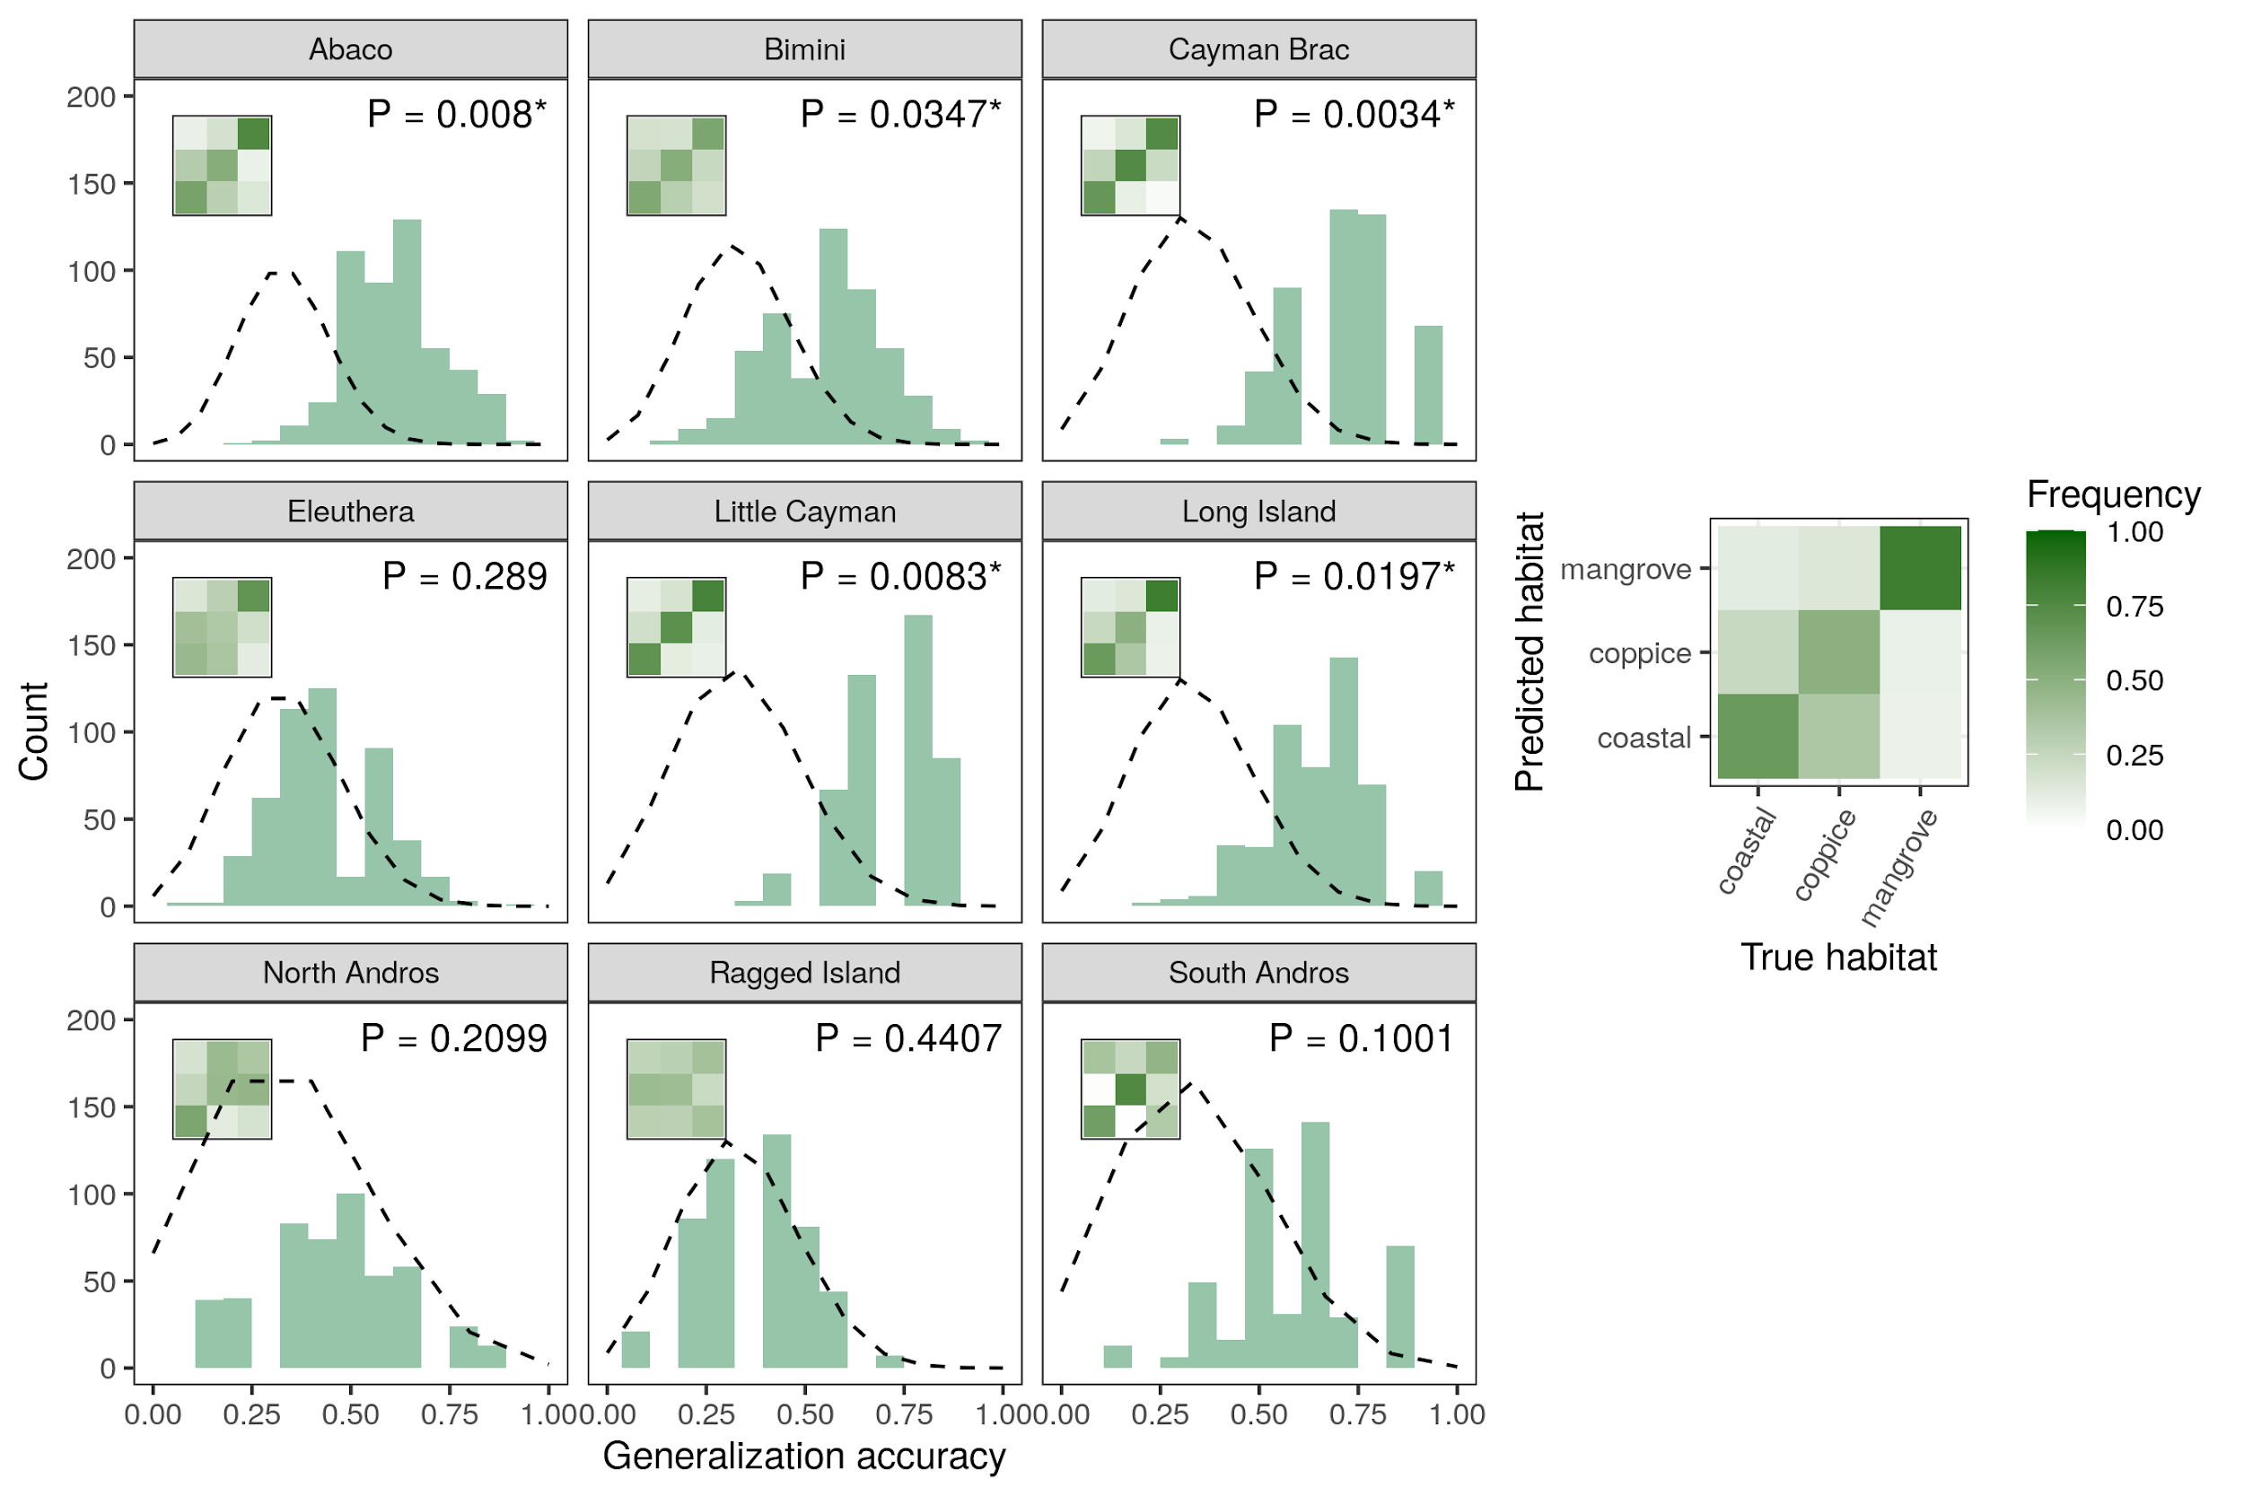

*Figure 2: SVM classification accuracy across islands based on principal component data. Histograms show accuracy distributions over 100 replicates for each five cross-validation bins per island. The dashed line is the density of a corresponding null binomial distribution, which would be expected under random guessing (testing sets with 20% of the observations for each island and success probability of $1/3$). Inset plots show the corresponding average confusion matrices and represent the proportion of lizards from each habitat (columns) reassigned in each other habitat (rows), with an interpretation guide in the right panel. Binomial test P-values indicate deviations of the mean classification accuracy to the null distribution. *, P < 0.05.*

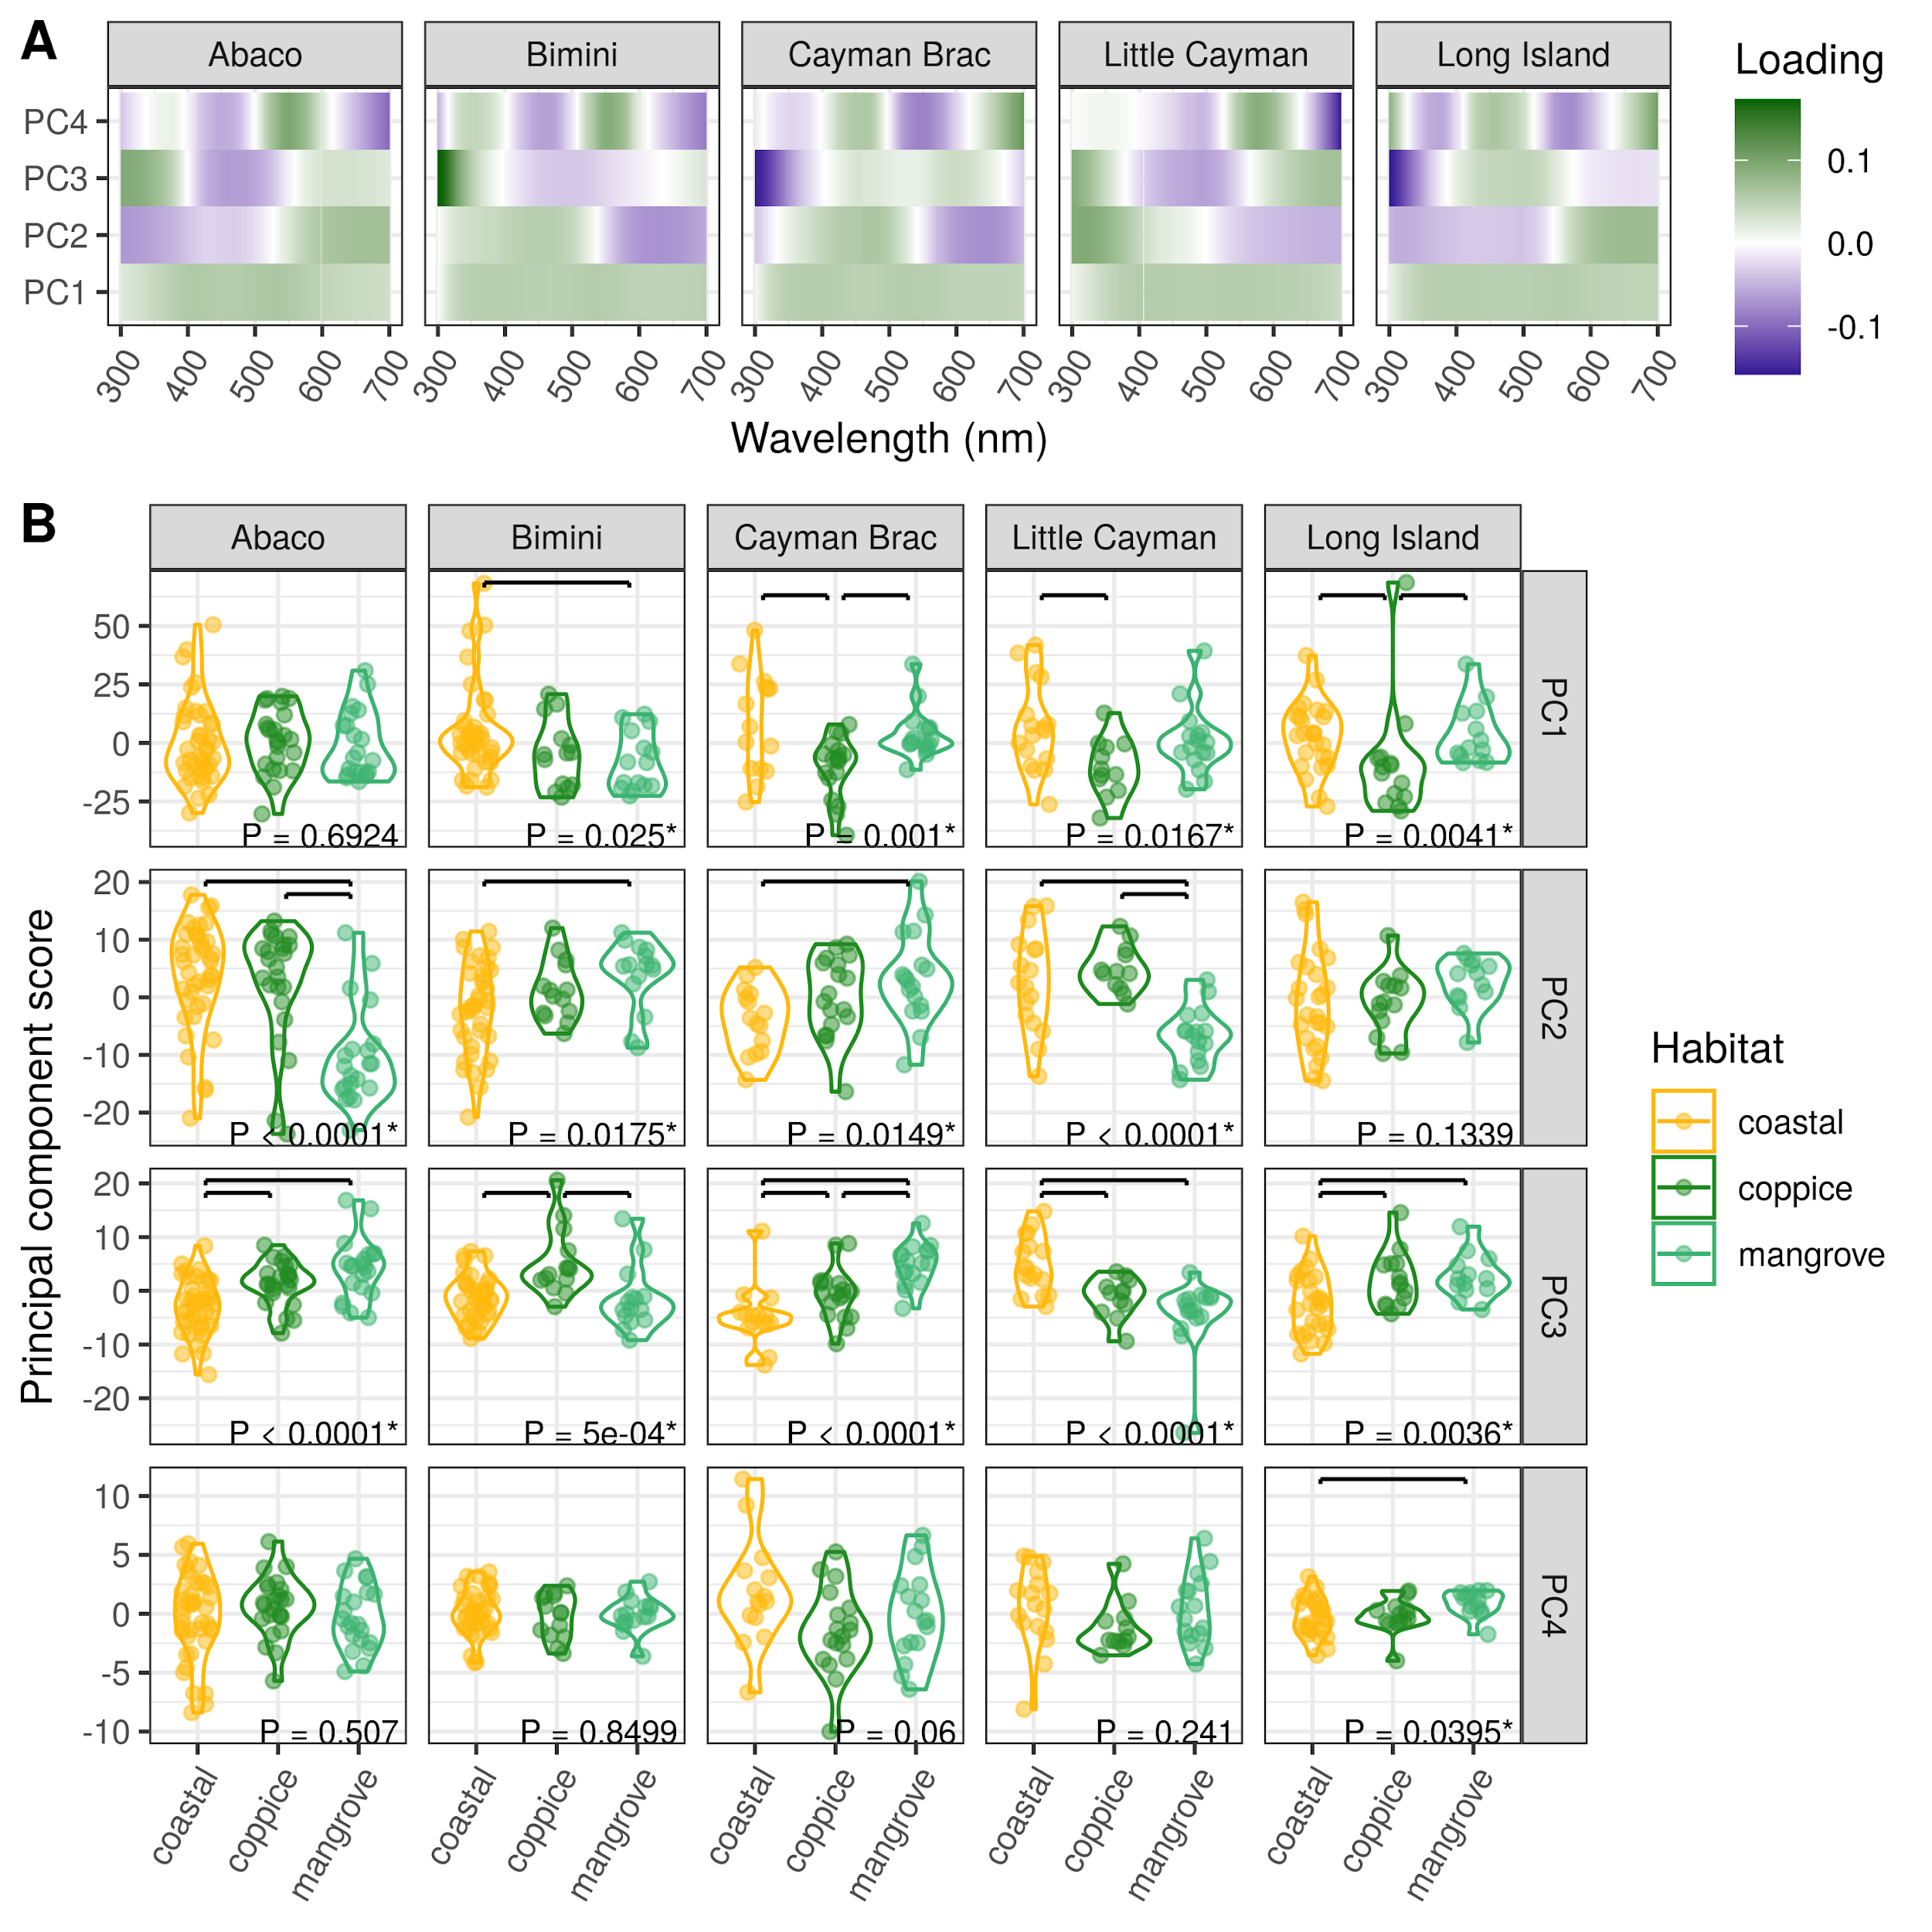

*Figure 3: Dewlap color variation between habitat-types across the most significant islands. (A) Mapping of reflectance at various wavelengths onto the principal components (loadings from the PCA rotation matrix). (B) Distribution of PC scores between habitats along the first four PCs on each island where significant between-habitat differences were detected using SVMs. P-values are reported for univariate ANOVA (or Kruskal-Wallis tests when applicable, see Methods). Post hoc significant differences at a 0.05 error rate are indicated with horizontal bars. *, P < 0.05.*

# Tables

|  |  |  |  |  |  |  |  |  |  |  |  |
| --- | --- | --- | --- | --- | --- | --- | --- | --- | --- | --- | --- |
| **Island** | **Variable** | **Best fit** | **df** | **AICc** | $Δ$**AICc** | **AICcw** | **df ${}_{LRT}$** | **Log-lik.** | $χ^{2}$ | $P$ |  |
| Abaco | PC1 | 1 | 4 | 710.4 | 0.0 | 0.746 | 2 | -357.0 | 0.14 | 0.9308 |  |
| Abaco | PC2 | 1 | 4 | 620.1 | 0.0 | 0.882 | 2 | -310.2 | 31.74 | 0.0000 | *** |
| Abaco | PC3 | 1 | 4 | 517.8 | 0.0 | 0.732 | 2 | -257.2 | 27.37 | 0.0000 | *** |
| Abaco | PC4 | 1 | 4 | 440.6 | 0.0 | 0.596 | 2 | -217.2 | 1.36 | 0.5070 |  |
| Bimini | PC1 | 1 | 4 | 561.3 | 0.0 | 0.595 | 2 | -283.1 | 7.40 | 0.0248 | * |
| Bimini | PC2 | 1 | 4 | 448.1 | 0.0 | 0.656 | 2 | -223.8 | 8.09 | 0.0175 | * |
| Bimini | PC3 | 2 | 6 | 405.3 | -0.2 | 0.529 | 2 | -199.2 | 10.39 | 0.0056 | ** |
| Bimini | PC4 | 1 | 4 | 274.2 | 0.0 | 0.854 | 2 | -132.7 | 0.33 | 0.8499 |  |
| Cayman Brac | PC1 | 2 | 6 | 402.8 | -4.1 | 0.884 | 2 | -200.9 | 13.81 | 0.0010 | ** |
| Cayman Brac | PC2 | 1 | 4 | 332.1 | 0.0 | 0.853 | 2 | -165.9 | 8.41 | 0.0149 | * |
| Cayman Brac | PC3 | 1 | 4 | 295.8 | 0.0 | 0.800 | 2 | -146.6 | 27.16 | 0.0000 | *** |
| Cayman Brac | PC4 | 1 | 4 | 279.2 | 0.0 | 0.897 | 2 | -137.8 | 5.63 | 0.0600 |  |
| Little Cayman | PC1 | 1 | 4 | 367.2 | 0.0 | 0.777 | 2 | -186.0 | 8.18 | 0.0167 | * |
| Little Cayman | PC2 | 2 | 6 | 287.6 | -3.6 | 0.859 | 2 | -140.5 | 29.76 | 0.0000 | *** |
| Little Cayman | PC3 | 1 | 4 | 277.7 | 0.0 | 0.669 | 2 | -138.1 | 21.34 | 0.0000 | *** |
| Little Cayman | PC4 | 1 | 4 | 226.7 | 0.0 | 0.780 | 2 | -110.7 | 2.85 | 0.2410 |  |
| Long Island | PC1 | 2 | 6 | 442.3 | -2.1 | 0.740 | 2 | -221.2 | 2.91 | 0.2331 |  |
| Long Island | PC2 | 2 | 6 | 351.4 | -3.1 | 0.823 | 2 | -172.6 | 4.52 | 0.1043 |  |
| Long Island | PC3 | 1 | 4 | 322.1 | 0.0 | 0.862 | 2 | -160.0 | 11.24 | 0.0036 | ** |
| Long Island | PC4 | 1 | 4 | 195.5 | 0.0 | 0.767 | 2 | -92.9 | 6.46 | 0.0395 | * |

[tab:anova]

# Supplementary Figures

*Figure S1. Map of the sampling sites and corresponding habitats across nine islands of the West Indies.*

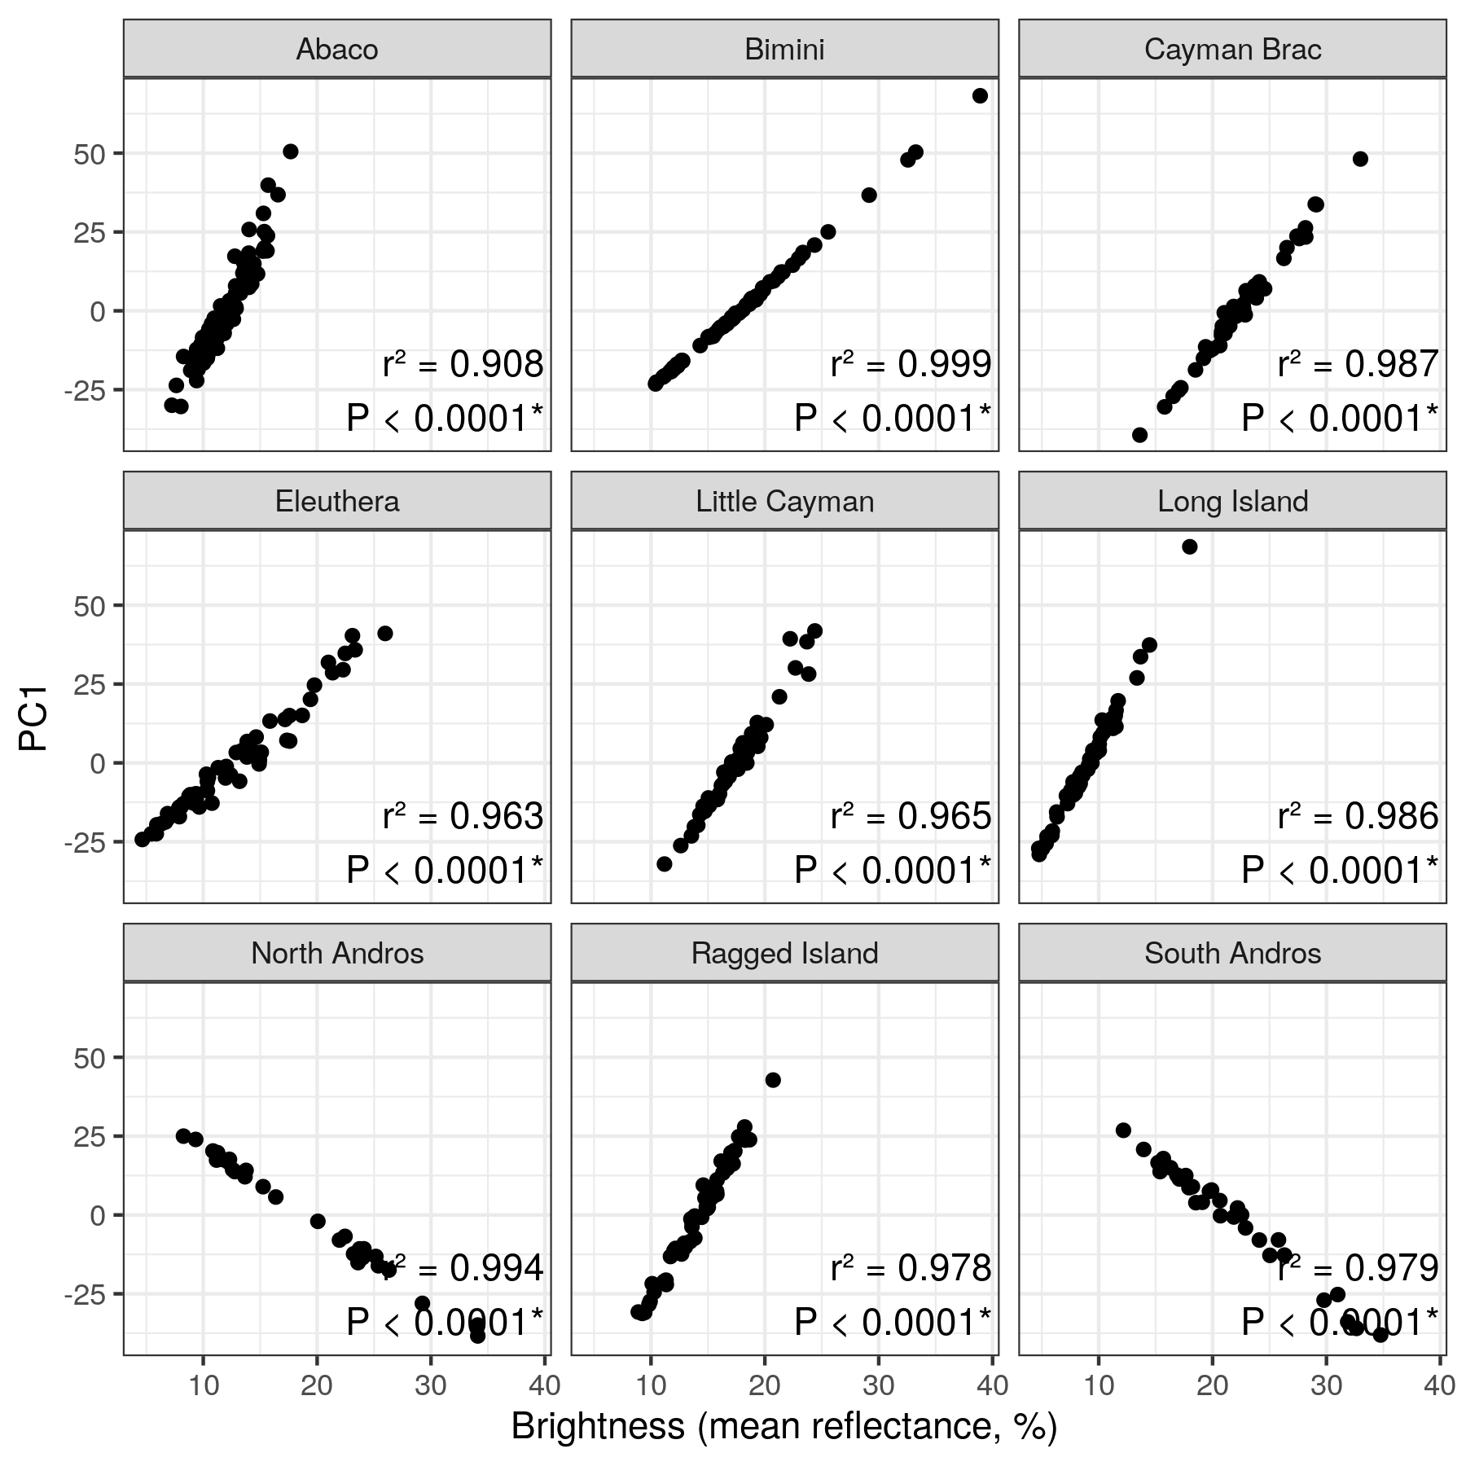

*Correlation between dewlap brightness (as measured by the mean reflectance from 300 to 700nm in wavelength) and PC1 score for each island. Pearson’s squared correlation coefficients are reported. *, P < 0.05.*

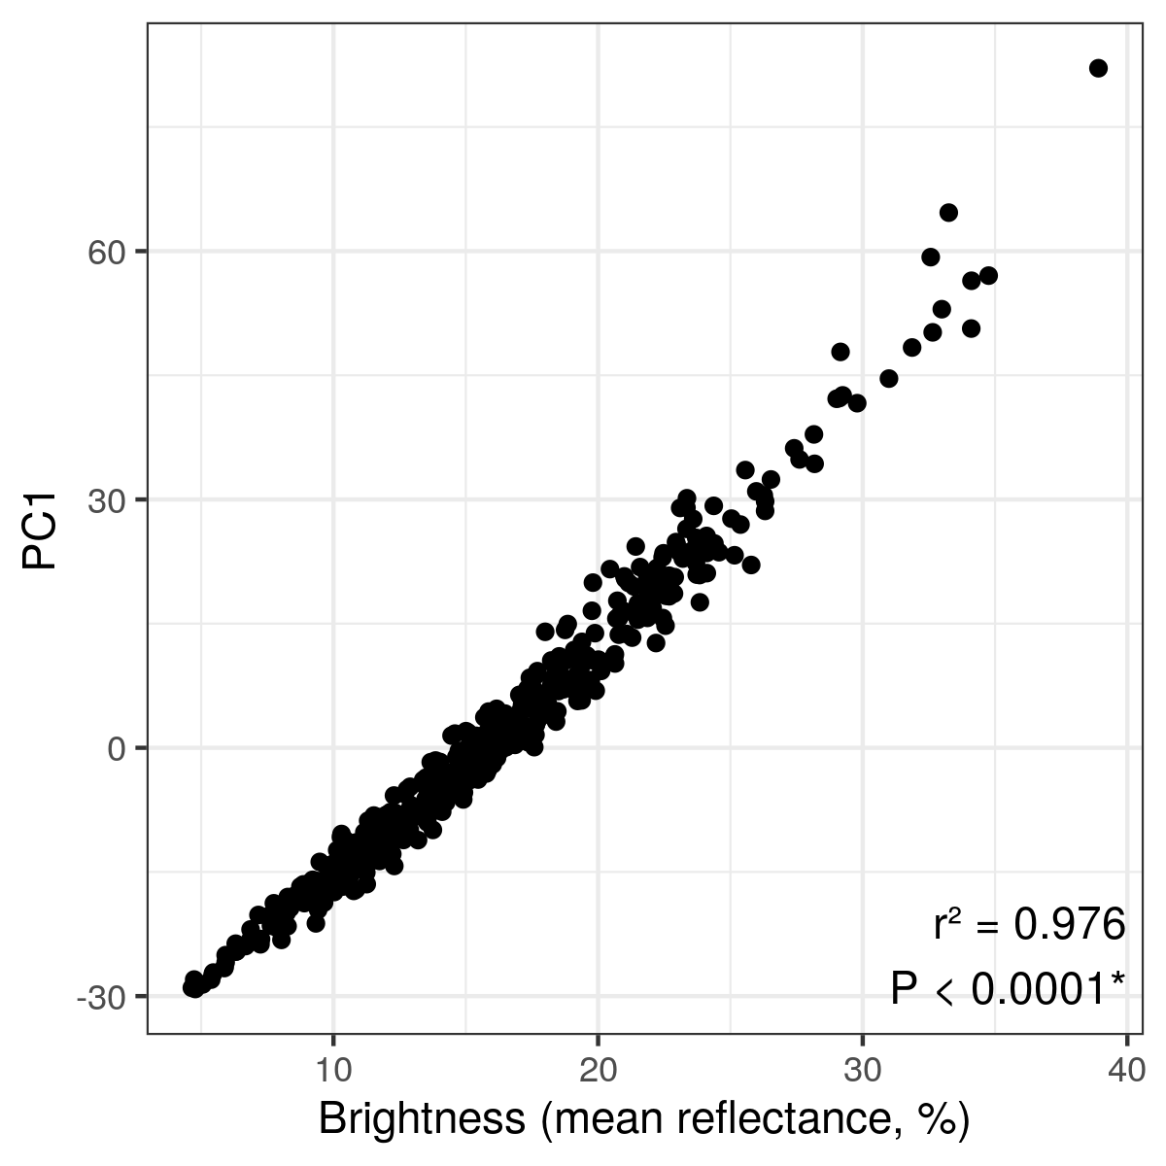

*Correlation between dewlap brightness (as measured by the mean reflectance from 300 to 700nm in wavelength) and PC1 score across the whole archipelago. Pearson’s squared correlation coefficient is reported. *, P < 0.05.*

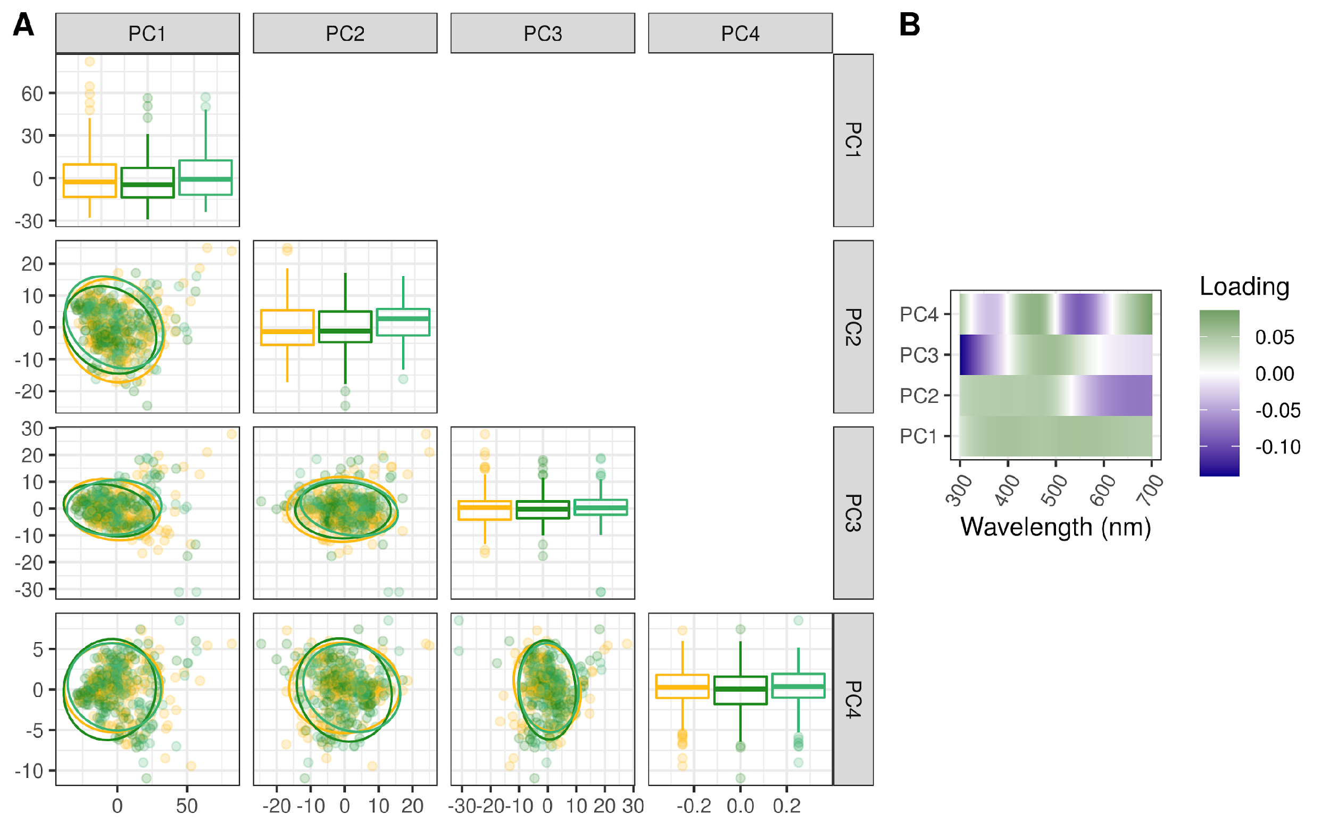

*(A) Principal component scores and 5% confidence ellipses across habitats for the whole archipelago. The principal component analysis was performed on reflectance data from all islands pooled together. (B) PCA rotation matrix showing the loadings of each wavelength from 300 to 700nm onto the principal components.*

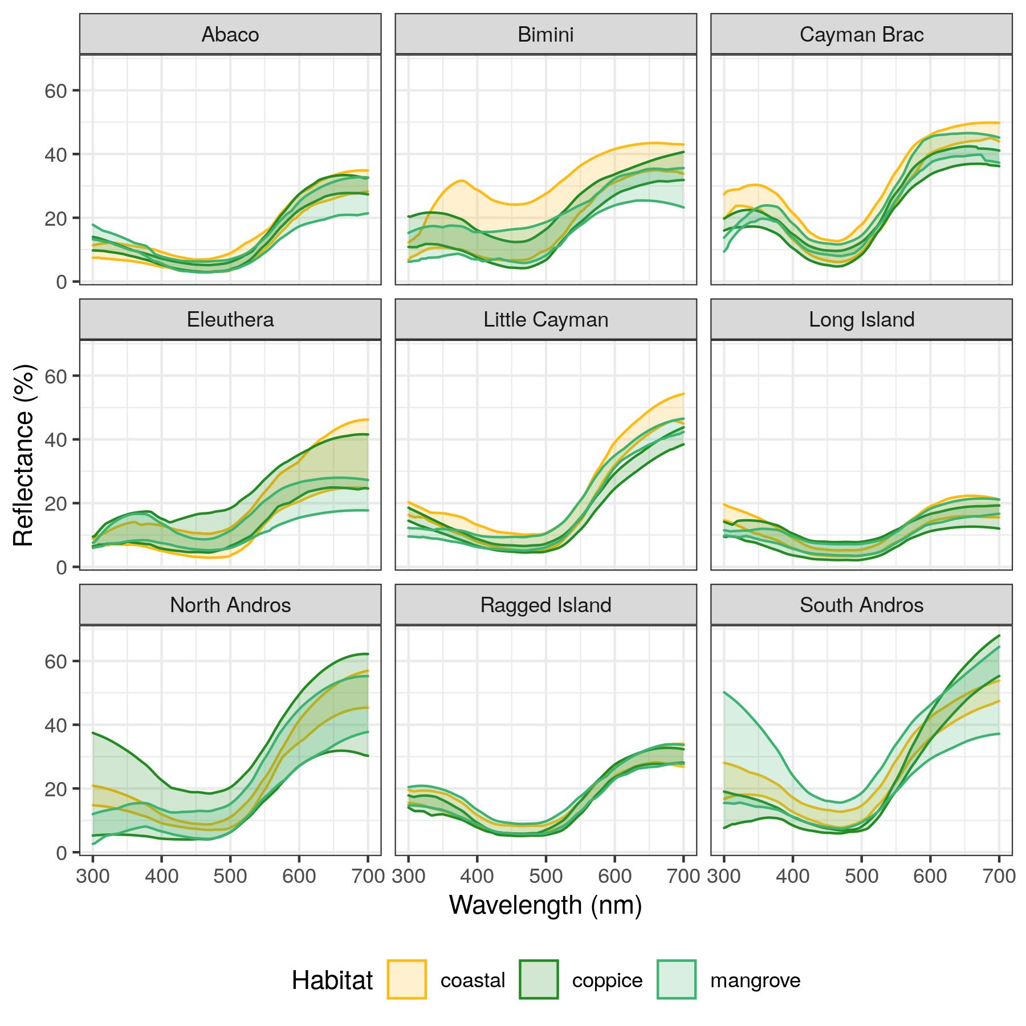

*5-95th percentile range of lizard dewlap reflectance values (in % of incoming light) across wavelengths for each island and each habitat.*

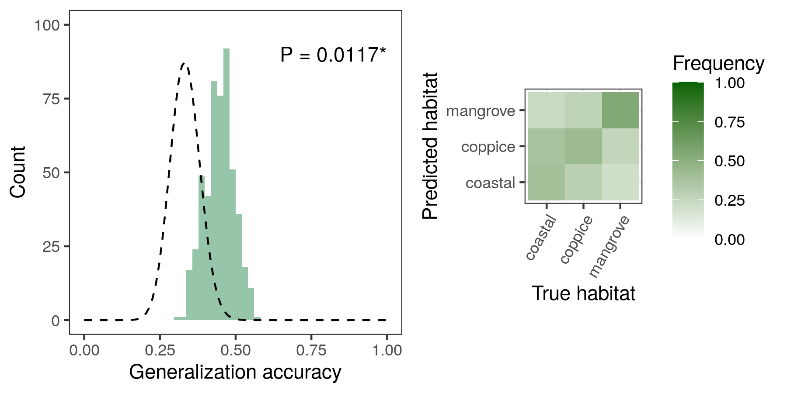

*Archipelago-wide SVM classification accuracy based on principal component data. Machines were trained on individual dewlaps regardless of island identity. The histogram shows the accuracy distribution over 100 replicates for each five cross-validation bins. The legend is the same as in Figure* *2**.*

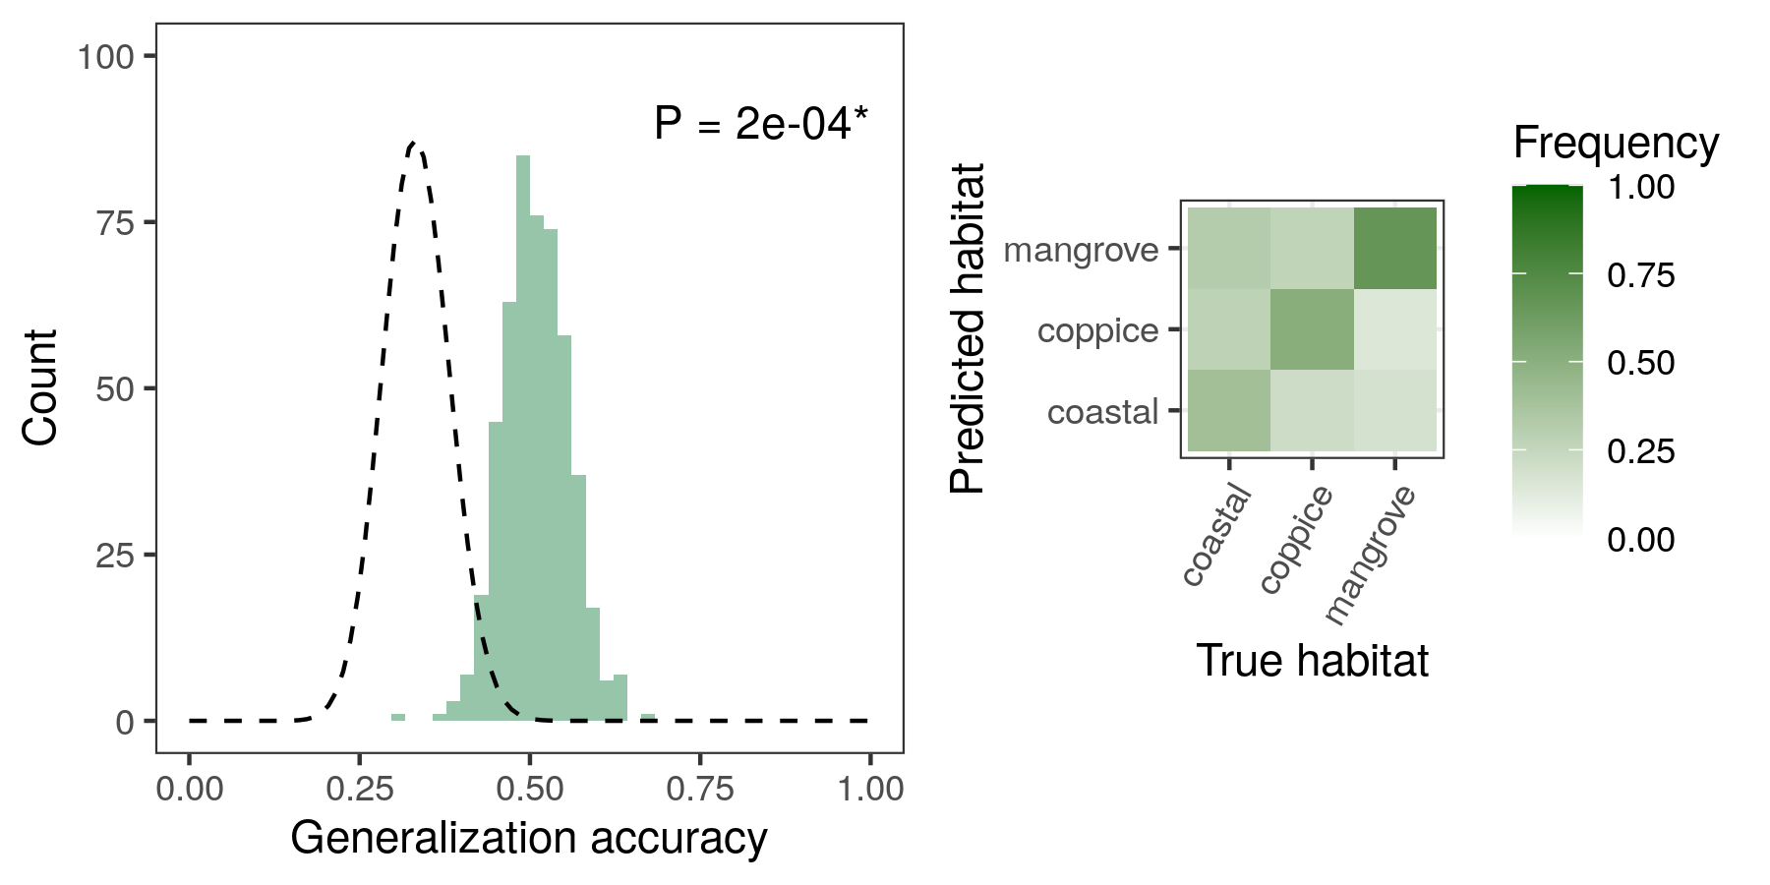

*Archipelago-wide SVM classification accuracy based on reflectance data at 50nm-intervals in wavelength (see Methods). Machines were trained on individual dewlaps regardless of island identity. The histogram shows the accuracy distribution over 100 replicates for each five cross-validation bins. The legend is the same as in Figure* *2**.*

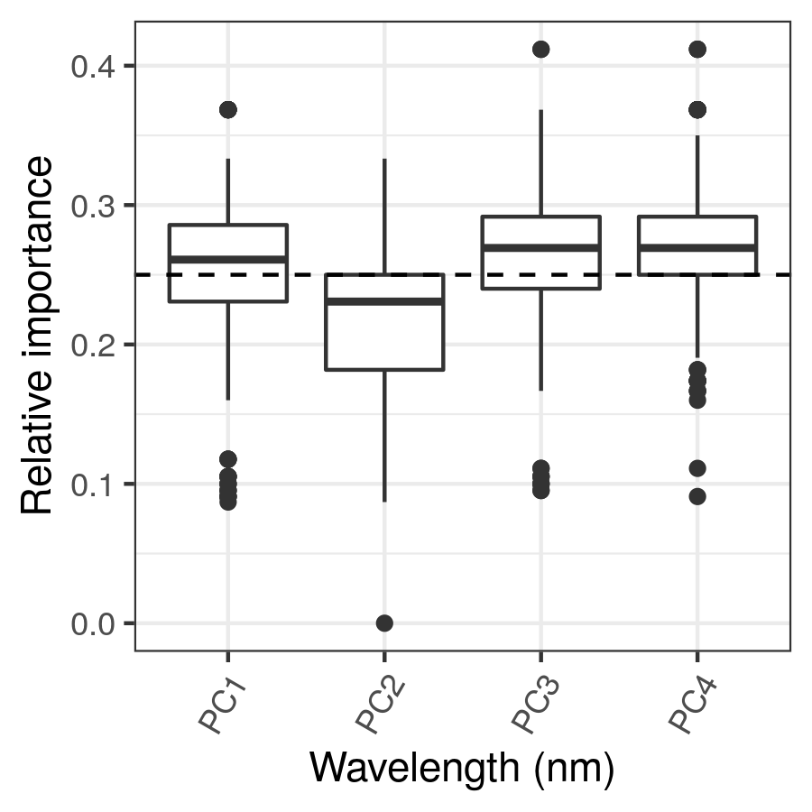

*Sensitivity analyses of the different input variables in the archipelago-wide SVM classification on principal component data (Figure* *9**), with relative importance computed for every machine.*

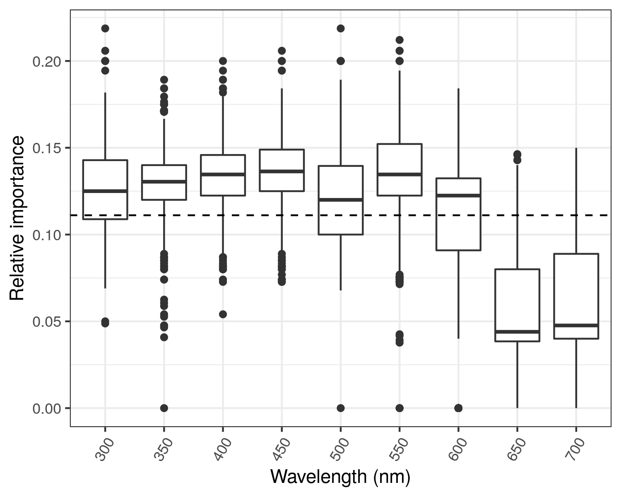

*Sensitivity analyses of the different input variables in the archipelago-wide SVM classification on reflectance data at 50nm-intervals in wavelength (Figure* *10**), with relative importance computed for every machine.*

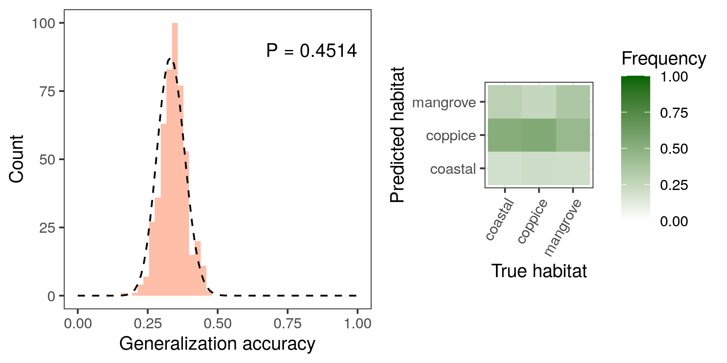

*Archipelago-wide LDA classification accuracy based on principal component data. Machines were trained on individual dewlaps regardless of island identity. The histogram shows the accuracy distribution over 100 replicates for each five cross-validation bins. The legend is the same as in Figure* *2**.*

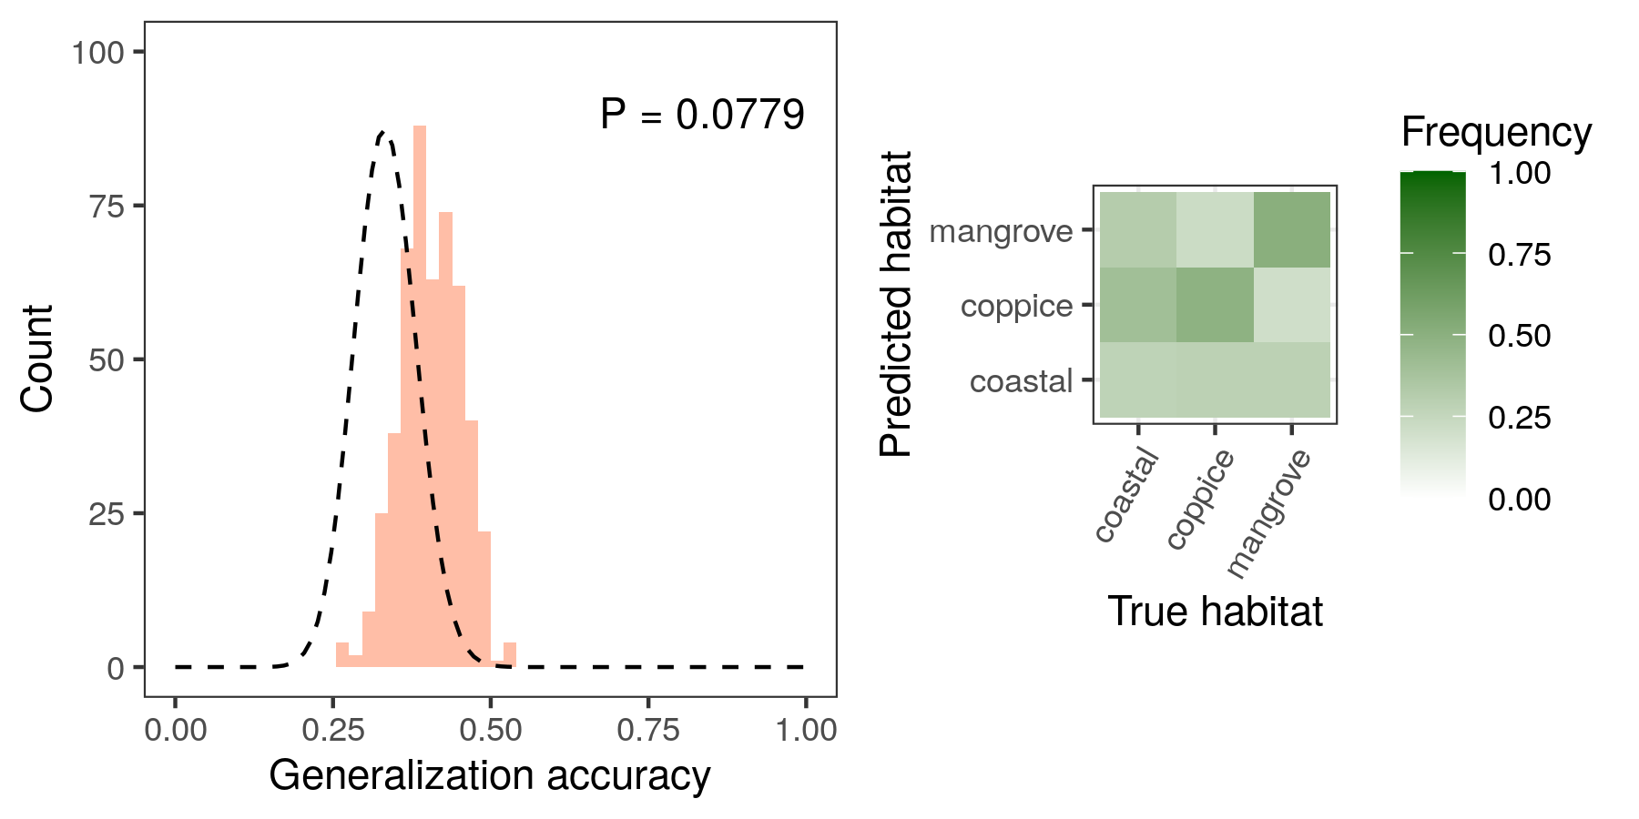

*Archipelago-wide LDA classification accuracy based on reflectance data at 50nm-intervals in wavelength (see Methods). Machines were trained on individual dewlaps regardless of island identity. The histogram shows the accuracy distribution over 100 replicates for each five cross-validation bins. The legend is the same as in Figure* *2**.*

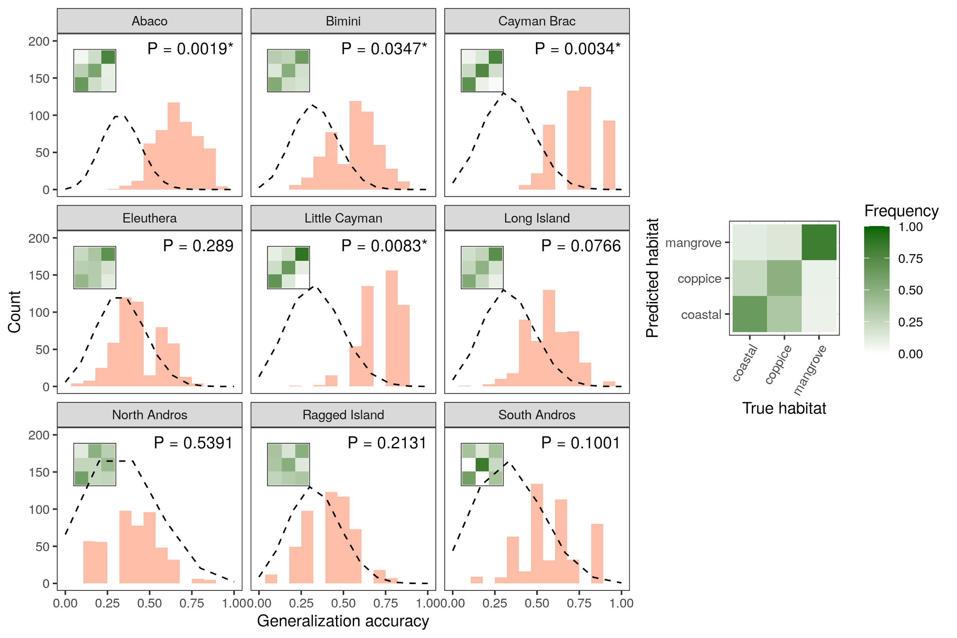

*LDA classification accuracy across islands based on principal component data. Histograms show accuracy distributions over 100 replicates for each five cross-validation bins per island. The legend is the same as in Figure* *2**.*

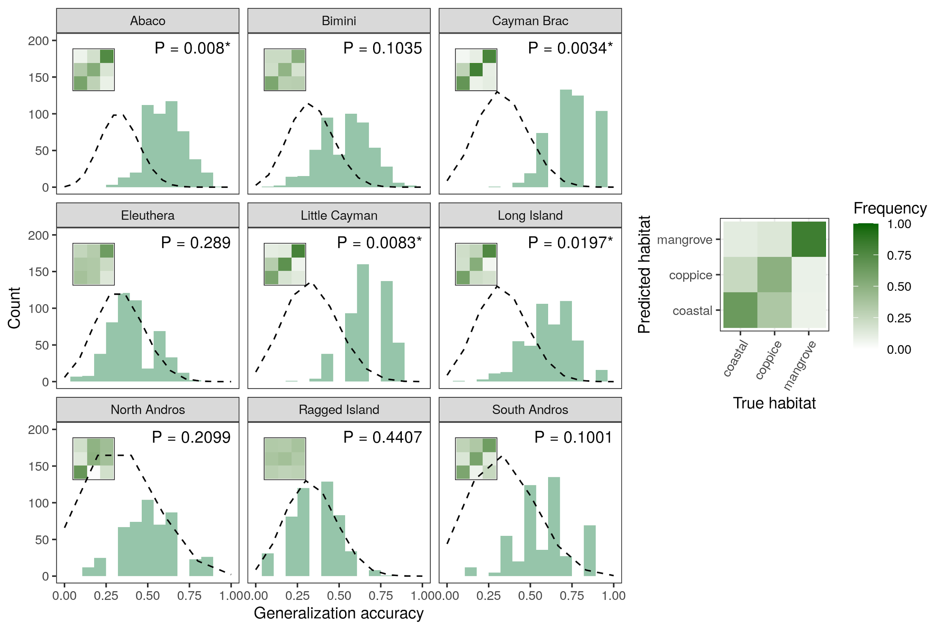

*SVM classification accuracy across islands based on reflectance data at 50nm-intervals in wavelength (see Methods). Histograms show accuracy distributions over 100 replicates for each five cross-validation bins per island. The legend is the same as in Figure* *2**.*

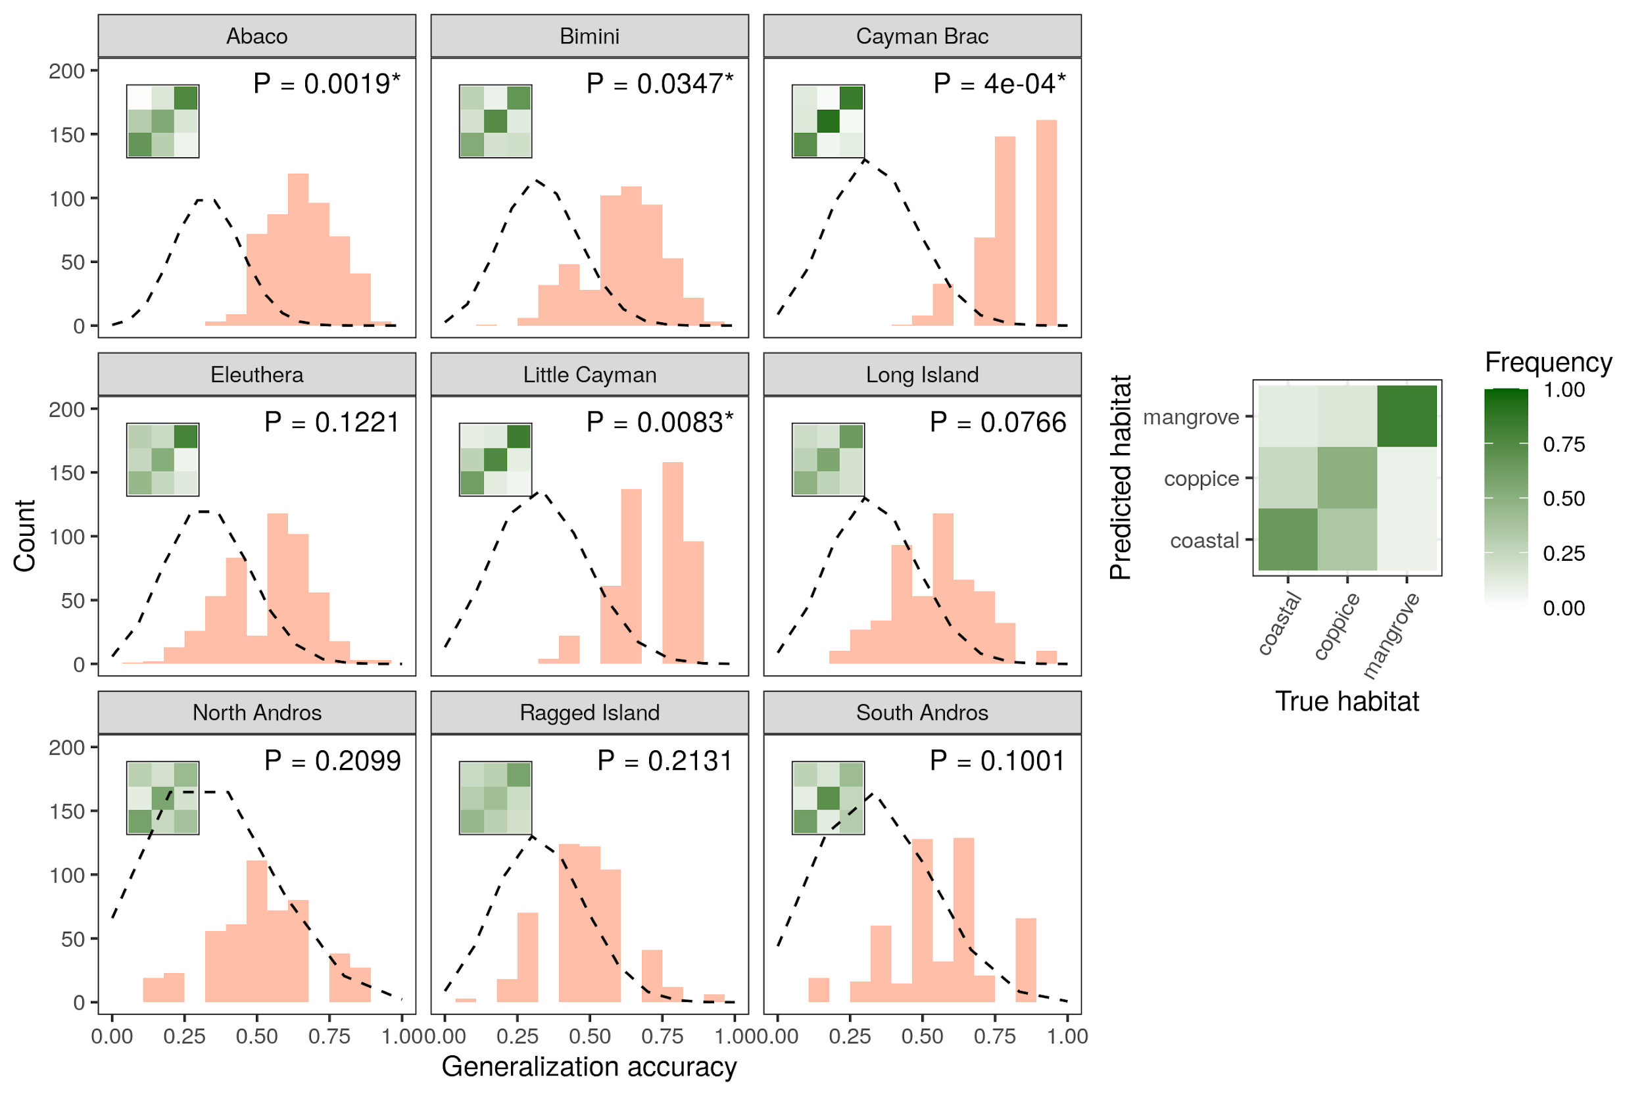

*LDA classification accuracy across islands based on reflectance data at 50nm-intervals in wavelength (see Methods). Histograms show accuracy distributions over 100 replicates for each five cross-validation bins per island. The legend is the same as in Figure* *2**.*

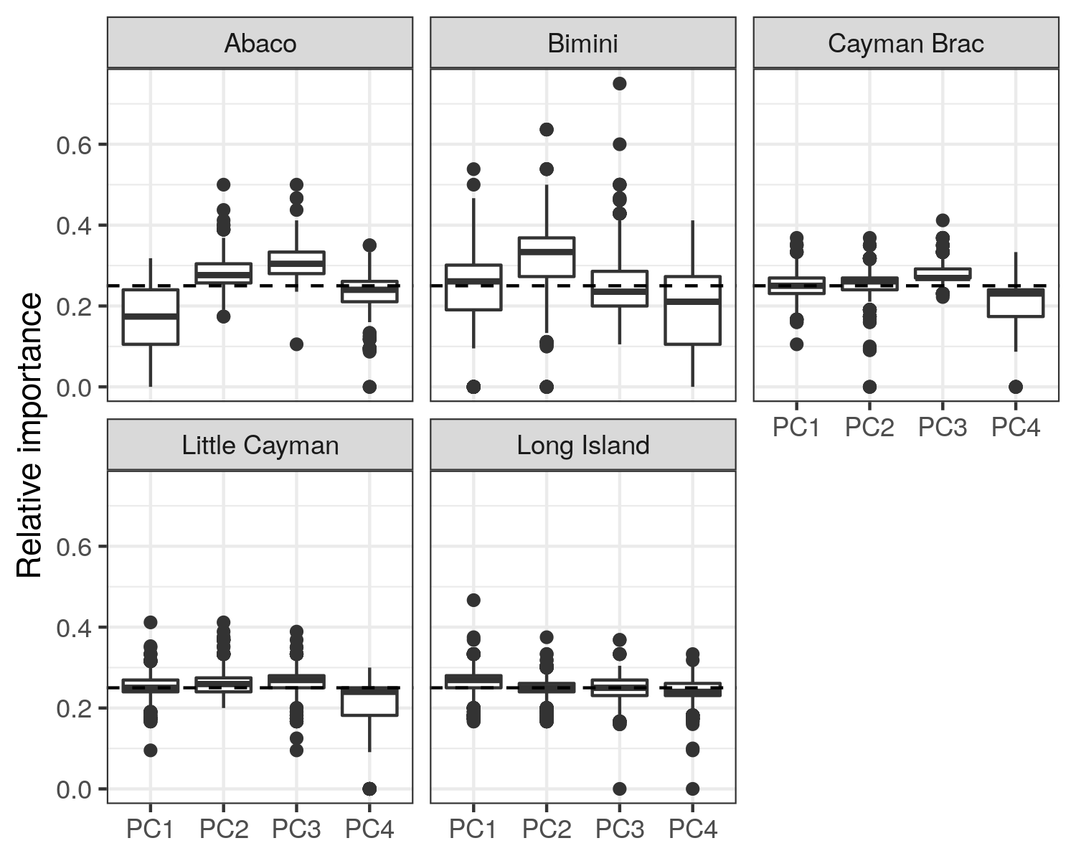

*Sensitivity analyses of the different input variables in the within-island SVM classification on principal component data (Figure* *[supfig:classif-svm-pca]**), with relative importance computed for every machine.*

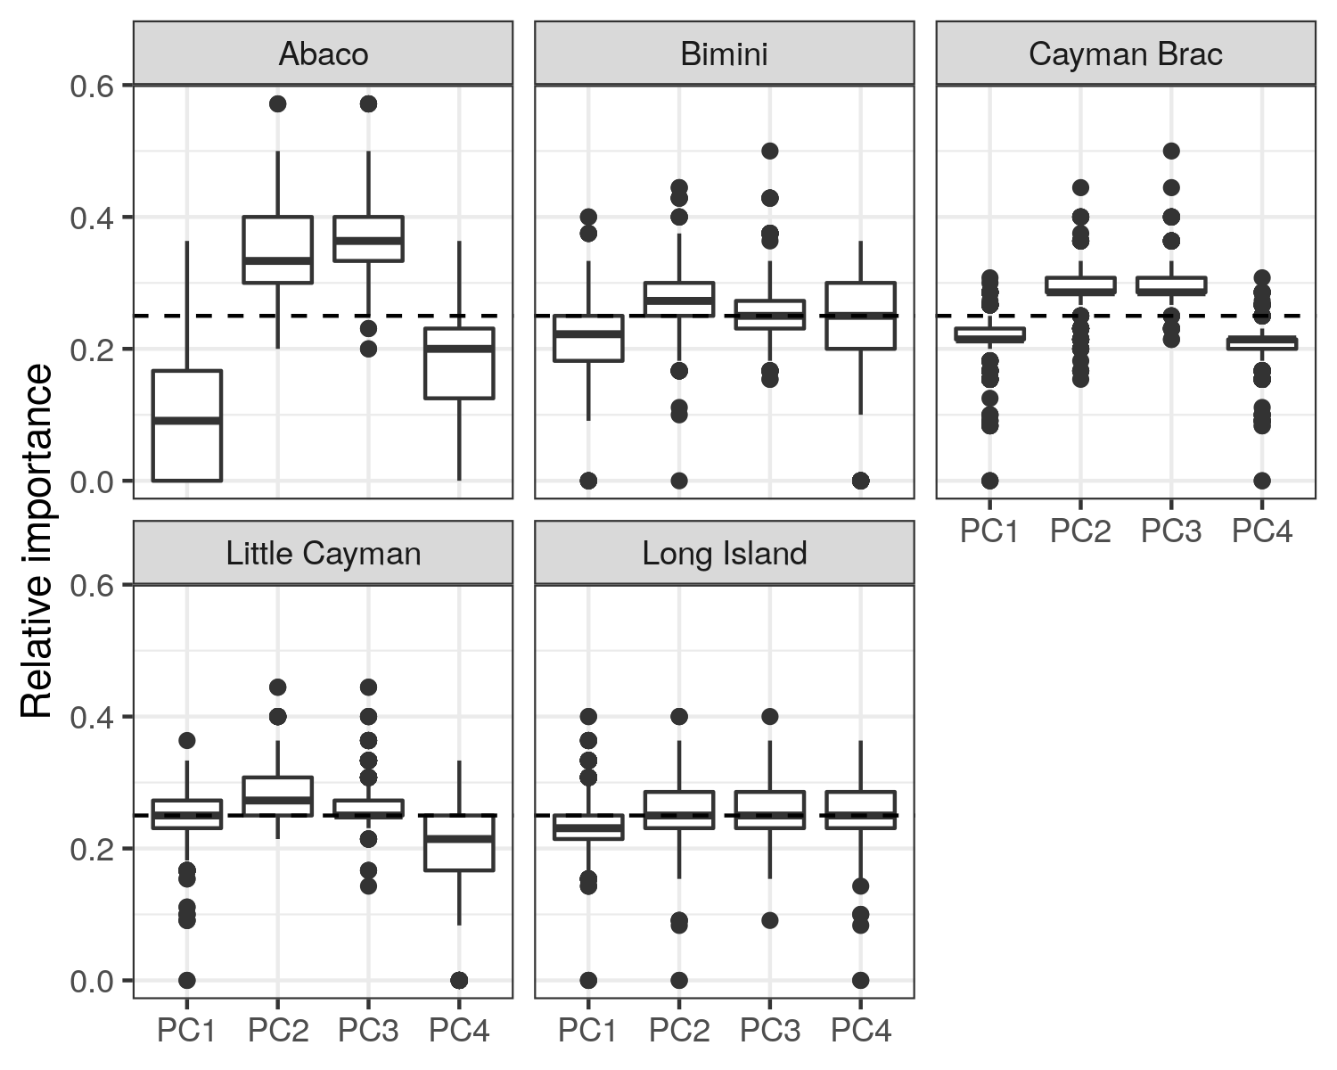

*Sensitivity analyses of the different input variables in the within-island LDA classification on principal component data (Figure* *15**), with relative importance computed for every machine.*



*Sensitivity analyses of the different input variables in the archipelago-wide SVM classification on reflectance at 50nm-intervals in wavelength (Figure* *16**), with relative importance computed for every machine.*



*Sensitivity analyses of the different input variables in the archipelago-wide LDA classification on reflectance at 50nm-intervals in wavelength (Figure* *17**), with relative importance computed for every machine.*

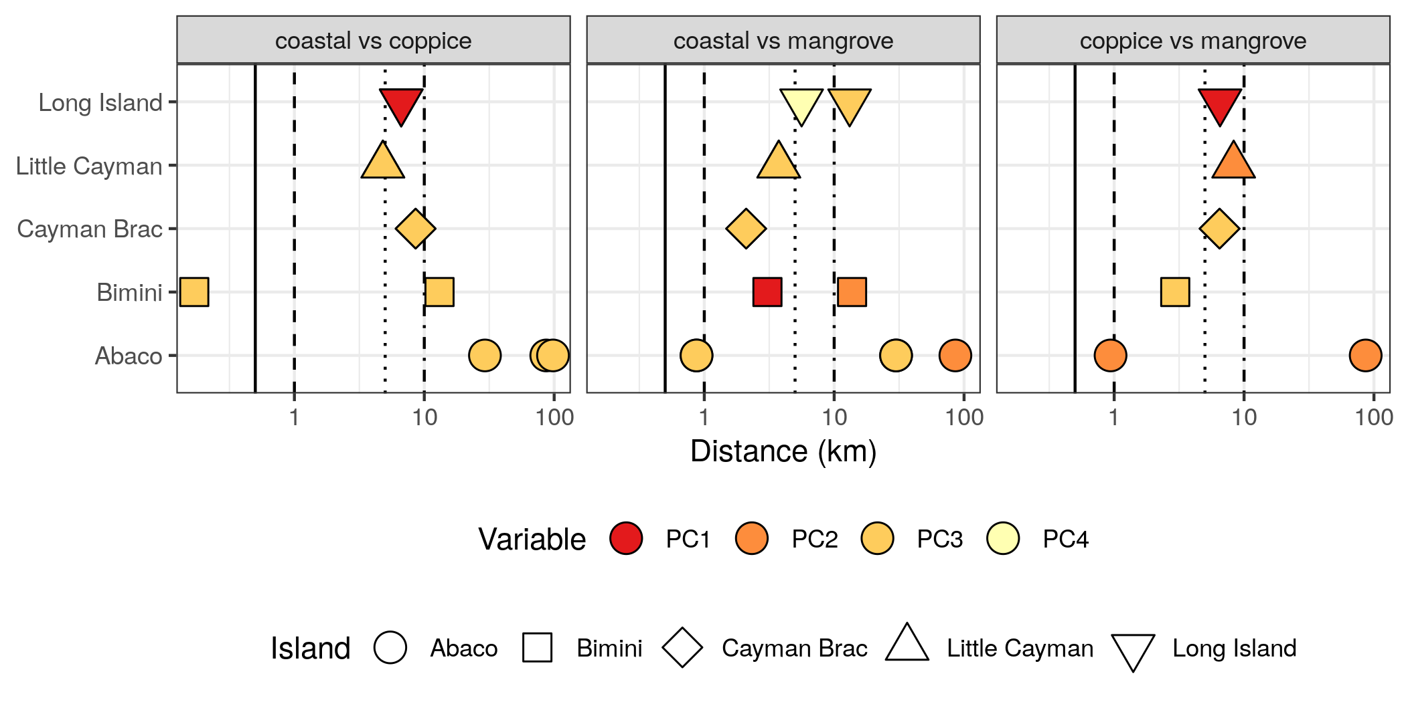

*Spatial scale of between-habitat differences in dewlap coloration. For each variable and each pair of habitats where significant differences were detected (Figure* *3**), we performed multiple post hoc pairwise comparisons between the sites involved (Figure* *4**, Table* *2**), using nonparametric Wilcoxon-Mann-Whitney tests. Here we report, for each pair of habitats, the distances between sites that significantly differed in dewlap coloration at an error rate of 0.05 (P-values corrected with the Benjamini-Hochberg procedure for multiple testing).*

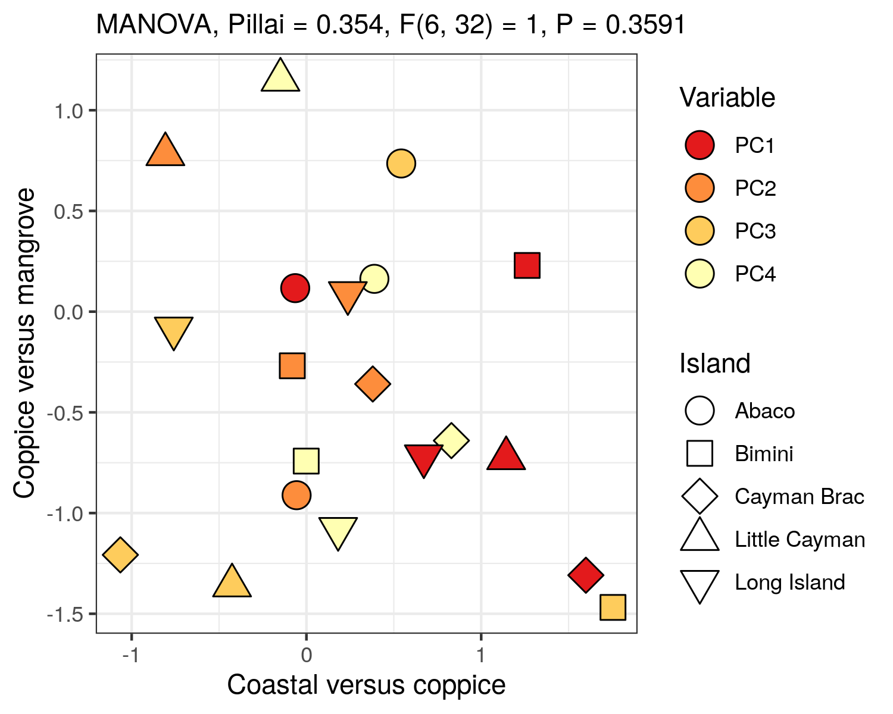

*Test of parallel divergence between islands. Differences in habitat-means, or contrasts, are shown for two pairs of habitats for each principal component on each island, rescaled so the standard deviation of the means along each principal component is one. The contrasts represent the patterns of between-habtiat variation on each island, for a given principal component. The absence of clustering of islands by variable indicates that islands differ in their between-habitat divergence patterns. This is confirmed by a non-significant MANOVA test of the between versus within-variable variance in contrasts.*

# Supplementary Tables

Number of lizards sampled in each habitat on each island.

|  |  |  |  |
| --- | --- | --- | --- |
|  | **coastal** | **coppice** | **mangrove** |
| Abaco | 41 | 24 | 21 |
| Bimini | 38 | 14 | 15 |
| Cayman Brac | 15 | 18 | 17 |
| Eleuthera | 22 | 25 | 9 |
| Little Cayman | 17 | 12 | 16 |
| Long Island | 26 | 14 | 13 |
| North Andros | 9 | 9 | 10 |
| Ragged Island | 18 | 15 | 17 |
| South Andros | 10 | 9 | 12 |

[suptab:counts]

Locations of the sampling sites across islands, with mean principal component scores per site.

|  |  |  |  |  |  |  |  |
| --- | --- | --- | --- | --- | --- | --- | --- |
| **Island** | **Longitude** | **Latitude** | **Habitat** | **PC1** | **PC2** | **PC3** | **PC4** |
| Abaco | -77.7256 | 26.9083 | mangrove | -5.4905 | 1.3541 | -0.4741 | 0.0083 |
| Abaco | -77.5800 | 26.9020 | coastal | 1.8633 | 0.0365 | -0.4475 | 0.0033 |
| Abaco | -77.5763 | 26.9128 | coppice | -1.6738 | -1.7793 | -0.0499 | 0.0012 |
| Abaco | -77.1784 | 26.1045 | coastal | 1.1863 | 2.0408 | -0.3468 | 0.0022 |
| Abaco | -77.0055 | 26.3254 | mangrove | -9.0319 | -2.7460 | 0.4687 | 0.0077 |
| Abaco | -77.0039 | 26.3170 | coppice | 0.9967 | 0.5161 | -0.0267 | -0.0118 |
| Abaco | -76.9968 | 26.3260 | coastal | 7.6077 | 0.3186 | 0.1771 | -0.0008 |
| Bimini | -79.3022 | 25.5859 | coastal | 5.7537 | -0.1593 | -0.2505 | 0.0001 |
| Bimini | -79.3014 | 25.7052 | coastal | -3.1822 | 1.6617 | -0.0460 | 0.0024 |
| Bimini | -79.3002 | 25.7042 | coppice | -1.3514 | -3.8786 | 0.1027 | -0.0027 |
| Bimini | -79.2709 | 25.7066 | mangrove | 3.3656 | 0.6244 | 0.1569 | -0.0021 |
| Cayman Brac | -79.8627 | 19.6878 | coastal | 6.6606 | -2.5670 | 0.0166 | -0.0007 |
| Cayman Brac | -79.8441 | 19.6949 | mangrove | -1.0914 | 4.3607 | 0.0855 | 0.0001 |
| Cayman Brac | -79.7887 | 19.7209 | coppice | -4.5197 | -1.9793 | -0.0946 | 0.0004 |
| Eleuthera | -76.3347 | 24.8146 | coppice | 3.2669 | -1.2404 | 0.1018 | -0.0085 |
| Eleuthera | -76.3058 | 24.8127 | coastal | 0.4216 | -3.5133 | -0.0567 | 0.0009 |
| Eleuthera | -76.2901 | 24.7981 | mangrove | 2.1881 | 0.7517 | 0.3957 | -0.0055 |
| Eleuthera | -76.1616 | 24.9129 | coppice | -1.9136 | 1.0868 | -0.4978 | -0.0092 |
| Eleuthera | -76.1492 | 24.9335 | coastal | -3.1863 | 2.4270 | 0.1881 | 0.0218 |
| Little Cayman | -80.0660 | 19.6906 | coppice | 0.8021 | -1.9569 | -0.0760 | -0.0068 |
| Little Cayman | -80.0205 | 19.6865 | coastal | -6.6917 | -1.2615 | 0.0659 | 0.0057 |
| Little Cayman | -79.9871 | 19.6986 | mangrove | 6.5083 | 2.8079 | -0.0129 | -0.0010 |
| Long Island | -75.2299 | 23.4740 | mangrove | -1.2873 | 1.9371 | -0.1880 | -0.0029 |
| Long Island | -75.2063 | 23.4282 | coastal | 2.3686 | -0.9033 | 0.0215 | 0.0096 |
| Long Island | -75.1884 | 23.4292 | coppice | -4.6266 | 0.5060 | 0.1049 | -0.0070 |
| Long Island | -75.1408 | 23.3883 | coastal | 3.6139 | -1.4521 | 0.0475 | 0.0025 |
| North Andros | -77.8908 | 24.8391 | coastal | -2.1881 | -1.1236 | 0.0397 | -0.0060 |
| North Andros | -77.8428 | 24.7516 | coppice | -1.8115 | 0.0012 | -0.1678 | 0.0024 |
| North Andros | -77.7540 | 24.6644 | mangrove | 3.5997 | 1.0101 | 0.1153 | 0.0033 |
| Ragged Island | -75.7364 | 22.1768 | coppice | 3.2851 | -0.3274 | 0.1911 | -0.0013 |
| Ragged Island | -75.7314 | 22.2097 | coastal | -0.6412 | -0.8878 | -0.1293 | -0.0033 |
| Ragged Island | -75.7276 | 22.2045 | mangrove | -2.9188 | 1.5792 | -0.0034 | 0.0099 |
| Ragged Island | -75.7270 | 22.1973 | mangrove | -1.2210 | 0.7285 | -0.0721 | -0.0028 |
| South Andros | -77.6050 | 24.2027 | mangrove | -3.9253 | 0.4734 | 0.0477 | -0.0005 |
| South Andros | -77.5936 | 24.1289 | coppice | 6.1152 | -0.4925 | 0.0349 | 0.0012 |
| South Andros | -77.5453 | 24.0764 | coastal | -0.7933 | -0.1248 | -0.0887 | -0.0004 |

[suptab:sites]

Proportion of variance explained by the first four principal components on each island, as well as across the whole archipelago.

|  |  |  |  |  |  |
| --- | --- | --- | --- | --- | --- |
| **Island** | **PC1** | **PC2** | **PC3** | **PC4** | **Total** |
| Abaco | 0.400 | 0.279 | 0.147 | 0.079 | 0.906 |
| Bimini | 0.502 | 0.208 | 0.160 | 0.051 | 0.921 |
| Cayman Brac | 0.438 | 0.190 | 0.155 | 0.105 | 0.888 |
| Eleuthera | 0.490 | 0.233 | 0.138 | 0.066 | 0.926 |
| Little Cayman | 0.441 | 0.212 | 0.176 | 0.078 | 0.907 |
| Long Island | 0.515 | 0.205 | 0.161 | 0.043 | 0.925 |
| North Andros | 0.560 | 0.170 | 0.152 | 0.054 | 0.937 |
| Ragged Island | 0.483 | 0.226 | 0.127 | 0.072 | 0.907 |
| South Andros | 0.488 | 0.247 | 0.146 | 0.067 | 0.948 |
| Archipelago | 0.473 | 0.197 | 0.164 | 0.079 | 0.913 |

[suptab:pcavariances]

Pearson’s correlation test between dewlap brightness, as measured by the average reflectance between 300 and 700nm in wavelength, and PC1 scores, for all islands and across the whole archipelago. ***, P < 0.001.

|  |  |  |  |
| --- | --- | --- | --- |
| **Island** | $r^{2}$ | $P$ |  |
| Abaco | 0.908 | < 0.0001 | *** |
| Bimini | 0.999 | < 0.0001 | *** |
| Cayman Brac | 0.987 | < 0.0001 | *** |
| Eleuthera | 0.963 | < 0.0001 | *** |
| Little Cayman | 0.965 | < 0.0001 | *** |
| Long Island | 0.986 | < 0.0001 | *** |
| North Andros | 0.994 | < 0.0001 | *** |
| Ragged Island | 0.978 | < 0.0001 | *** |
| South Andros | 0.979 | < 0.0001 | *** |
| Archipelago | 0.976 | < 0.0001 | *** |

[suptab:brightness]

Henze-Zirkler’s test of multivariate normality, performed on principal components in each habitat and on each island. HZ, test statistic. *, P < 0.05; **, P < 0.01; ***, P < 0.001.

|  |  |  |  |  |
| --- | --- | --- | --- | --- |
| **Island** | **Habitat** | $HZ$ | $P$ |  |
| Abaco | coastal | 1.10 | 0.0027 | ** |
| Abaco | coppice | 1.07 | 0.0022 | ** |
| Abaco | mangrove | 1.06 | 0.0023 | ** |
| Bimini | coastal | 1.28 | 0.0001 | *** |
| Bimini | coppice | 0.85 | 0.0482 | * |
| Bimini | mangrove | 1.19 | 0.0001 | *** |
| Cayman Brac | coastal | 0.65 | 0.5311 |  |
| Cayman Brac | coppice | 0.70 | 0.3940 |  |
| Cayman Brac | mangrove | 0.66 | 0.5357 |  |
| Eleuthera | coastal | 1.61 | 0.0000 | *** |
| Eleuthera | coppice | 1.48 | 0.0000 | *** |
| Eleuthera | mangrove | 0.73 | 0.1423 |  |
| Little Cayman | coastal | 0.62 | 0.6599 |  |
| Little Cayman | coppice | 0.64 | 0.4867 |  |
| Little Cayman | mangrove | 0.87 | 0.0413 | * |
| Long Island | coastal | 0.82 | 0.1468 |  |
| Long Island | coppice | 0.92 | 0.0150 | * |
| Long Island | mangrove | 0.77 | 0.1289 |  |
| North Andros | coastal | 0.66 | 0.3174 |  |
| North Andros | coppice | 0.76 | 0.0900 |  |
| North Andros | mangrove | 0.67 | 0.3185 |  |
| Ragged Island | coastal | 0.76 | 0.2268 |  |
| Ragged Island | coppice | 0.80 | 0.1115 |  |
| Ragged Island | mangrove | 0.54 | 0.9022 |  |
| South Andros | coastal | 0.66 | 0.3451 |  |
| South Andros | coppice | 0.66 | 0.3154 |  |
| South Andros | mangrove | 0.91 | 0.0144 | * |

[suptab:multinorm]

Box’s M-test of homogeneity of covariance matrices across habitats on each island. $χ^{2}$, test statistic. *, P < 0.05; **, P < 0.01; ***, P < 0.001.

|  |  |  |  |  |
| --- | --- | --- | --- | --- |
| **Island** | $χ^{2}$ | **df** | $P$ |  |
| Abaco | 47.1 | 20 | 0.0006 | *** |
| Bimini | 36.0 | 20 | 0.0152 | * |
| Cayman Brac | 36.9 | 20 | 0.0120 | * |
| Eleuthera | 44.6 | 20 | 0.0013 | ** |
| Little Cayman | 32.8 | 20 | 0.0356 | * |
| Long Island | 56.2 | 20 | 0.0000 | *** |
| North Andros | 33.7 | 20 | 0.0283 | * |
| Ragged Island | 29.3 | 20 | 0.0824 |  |
| South Andros | 46.5 | 20 | 0.0007 | *** |

[suptab:covariance]

Shapiro-Wilk’s test of univariate normality performed on each island where significant differences were detected by SVM classification, in each habitat where deviations from multivariate normality were detected. $W$, test statistic. *, P < 0.05; **, P < 0.01; ***, P < 0.001.

|  |  |  |  |  |  |
| --- | --- | --- | --- | --- | --- |
| **Island** | **Habitat** | **Variable** | $W$ | $P$ |  |
| Abaco | coastal | PC1 | 0.954 | 0.0941 |  |
| Abaco | coastal | PC2 | 0.927 | 0.0112 | * |
| Abaco | coastal | PC3 | 0.973 | 0.4228 |  |
| Abaco | coastal | PC4 | 0.955 | 0.1027 |  |
| Abaco | coppice | PC1 | 0.970 | 0.6776 |  |
| Abaco | coppice | PC2 | 0.816 | 0.0005 | *** |
| Abaco | coppice | PC3 | 0.930 | 0.0976 |  |
| Abaco | coppice | PC4 | 0.941 | 0.1711 |  |
| Abaco | mangrove | PC1 | 0.881 | 0.0155 | * |
| Abaco | mangrove | PC2 | 0.869 | 0.0093 | ** |
| Abaco | mangrove | PC3 | 0.986 | 0.9873 |  |
| Abaco | mangrove | PC4 | 0.939 | 0.2044 |  |
| Bimini | coastal | PC1 | 0.821 | 0.0000 | *** |
| Bimini | coastal | PC2 | 0.960 | 0.1854 |  |
| Bimini | coastal | PC3 | 0.856 | 0.0002 | *** |
| Bimini | coastal | PC4 | 0.945 | 0.0611 |  |
| Bimini | coppice | PC1 | 0.911 | 0.1648 |  |
| Bimini | coppice | PC2 | 0.958 | 0.6927 |  |
| Bimini | coppice | PC3 | 0.953 | 0.6146 |  |
| Bimini | coppice | PC4 | 0.971 | 0.8953 |  |
| Bimini | mangrove | PC1 | 0.884 | 0.0536 |  |
| Bimini | mangrove | PC2 | 0.976 | 0.9363 |  |
| Bimini | mangrove | PC3 | 0.982 | 0.9805 |  |
| Bimini | mangrove | PC4 | 0.975 | 0.9232 |  |
| Eleuthera | coastal | PC1 | 0.909 | 0.0461 | * |
| Eleuthera | coastal | PC2 | 0.886 | 0.0157 | * |
| Eleuthera | coastal | PC3 | 0.906 | 0.0390 | * |
| Eleuthera | coastal | PC4 | 0.962 | 0.5293 |  |
| Eleuthera | coppice | PC1 | 0.922 | 0.0567 |  |
| Eleuthera | coppice | PC2 | 0.954 | 0.3055 |  |
| Eleuthera | coppice | PC3 | 0.781 | 0.0001 | *** |
| Eleuthera | coppice | PC4 | 0.901 | 0.0188 | * |
| Little Cayman | mangrove | PC1 | 0.907 | 0.1024 |  |
| Little Cayman | mangrove | PC2 | 0.904 | 0.0924 |  |
| Little Cayman | mangrove | PC3 | 0.739 | 0.0005 | *** |
| Little Cayman | mangrove | PC4 | 0.973 | 0.8802 |  |
| Long Island | coppice | PC1 | 0.686 | 0.0003 | *** |
| Long Island | coppice | PC2 | 0.848 | 0.0210 | * |
| Long Island | coppice | PC3 | 0.931 | 0.3188 |  |
| Long Island | coppice | PC4 | 0.904 | 0.1280 |  |
| South Andros | mangrove | PC1 | 0.787 | 0.0067 | ** |
| South Andros | mangrove | PC2 | 0.861 | 0.0500 | * |
| South Andros | mangrove | PC3 | 0.697 | 0.0008 | *** |
| South Andros | mangrove | PC4 | 0.950 | 0.6411 |  |

[suptab:normality]

Univariate ANOVAs performed on each principal component across the whole archipelago. Legend is the same as for Table [tab:anova], except that best fitting models 3 and 4 refer to the mixed effect equivalents to the OLS and GLS model, with island as a random effect (see Methods).

|  |  |  |  |  |  |  |  |  |  |  |
| --- | --- | --- | --- | --- | --- | --- | --- | --- | --- | --- |
| **Variable** | **Best fit** | **df** | **AICc** | $Δ$**AICc** | **AICcw** | **df ${}_{LRT}$** | **Log-lik.** | $χ^{2}$ | $P$ |  |
| PC1 | 3 | 5 | 3749.9 | -228.3 | 0.613 | 2 | -1874.7 | 8.69 | 0.0130 | * |
| PC2 | 4 | 7 | 3002.2 | -162.3 | 0.976 | 2 | -1496.2 | 17.76 | 0.0001 | *** |
| PC3 | 4 | 7 | 2826.3 | -175.4 | 0.968 | 2 | -1407.8 | 7.03 | 0.0298 | * |
| PC4 | 4 | 7 | 2015.7 | -305.8 | 0.519 | 2 | -1000.1 | 0.47 | 0.7914 |  |

[suptab:anova-pooled]

Mean SVM classification accuracy per island, over all replicates and cross-validation bins. $N$, number of observations per island; $p_{test}$, proportion of the data sampled to form the training set; $n_{test}$, number of observations in the testing set. P-values indicate deviations from the expected null binomial distribution, with $n_{test}$ events per island and random guess success probability $1/3$. *, P < 0.05, **, P < 0.01, ***, P < 0.001.

|  |  |  |  |  |  |  |
| --- | --- | --- | --- | --- | --- | --- |
| **Island** | **Accuracy** | $N$ | $p_{test}$ | $n_{test}$ | $P$ |  |
| Abaco | 0.612 | 86 | 0.2 | 17 | 0.0080 | ** |
| Bimini | 0.547 | 67 | 0.2 | 13 | 0.0347 | * |
| Cayman Brac | 0.721 | 50 | 0.2 | 10 | 0.0034 | ** |
| Eleuthera | 0.437 | 56 | 0.2 | 11 | 0.2890 |  |
| Little Cayman | 0.734 | 45 | 0.2 | 9 | 0.0083 | ** |
| Long Island | 0.651 | 53 | 0.2 | 10 | 0.0197 | * |
| North Andros | 0.453 | 28 | 0.2 | 5 | 0.2099 |  |
| Ragged Island | 0.364 | 50 | 0.2 | 10 | 0.4407 |  |
| South Andros | 0.600 | 31 | 0.2 | 6 | 0.1001 |  |

[suptab:classif-svm-pca]

Results of nonparametric Kruskal-Wallis tests performed on each variable on each island where deviations from normality were detected.

|  |  |  |  |  |  |
| --- | --- | --- | --- | --- | --- |
| **Island** | **Variable** | $χ^{2}$ | **df** | $P$ |  |
| Abaco | PC1 | 0.74 | 2 | 0.6924 |  |
| Abaco | PC2 | 23.13 | 2 | 0.0000 | *** |
| Bimini | PC1 | 7.38 | 2 | 0.0250 | * |
| Bimini | PC3 | 15.17 | 2 | 0.0005 | *** |
| Little Cayman | PC3 | 19.95 | 2 | 0.0000 | *** |
| Long Island | PC1 | 10.98 | 2 | 0.0041 | ** |
| Long Island | PC2 | 4.02 | 2 | 0.1339 |  |

[suptab:kruskal]

Individual-based permutation tests of spatial autocorrelation within islands. P-values were computed from 1,000 permutations of individual site-labels. Pearson’s coefficient $r$ measures the correlation between distances in color space and geodesic distances among the sites. $N$, number of sites. *, P < 0.05.

|  |  |  |  |  |
| --- | --- | --- | --- | --- |
| **Island** | $r$ | $P$ | $N$ |  |
| Abaco | -0.213 | 0.817 | 7 |  |
| Bimini | 0.044 | 0.510 | 4 |  |
| Cayman Brac | -0.010 | 0.465 | 3 |  |
| Eleuthera | 0.816 | 0.015 | 5 | * |
| Little Cayman | -0.688 | 0.684 | 3 |  |
| Long Island | -0.189 | 0.579 | 4 |  |
| North Andros | 0.730 | 0.199 | 3 |  |
| Ragged Island | 0.706 | 0.114 | 4 |  |
| South Andros | -0.852 | 0.776 | 3 |  |

[suptab:autocor]

Andersson, M.B. 1994. *Sexual selection*. Princeton University Press, Princeton, N.J.

Arnold, S.J. 1983. Morphology, Performance and Fitness. *American Zoologist* **23**: 347–361.

Baeckens, S., Driessens, T. & Van Damme, R. 2018. The brown anole dewlap revisited: Do predation pressure, sexual selection, and species recognition shape among-population signal diversity? *PeerJ* **6**: e4722.

Bartoń, K. 2019. MuMIn: Multi-Model Inference.

Benjamini, Y. & Hochberg, Y. 1995. Controlling the false discovery rate: A practical and powerful approach to multiple testing. *Journal of the Royal Statistical Society Series B* **57**: 289–300.

Box, G.E.P. 1949. A General Distribution Theory for a Class of Likelihood Criteria. *Biometrika* **36**: 317.

Bradbury, J.W. & Vehrencamp, S.L. 2011. *Principles of animal communication*, 2nd ed. Sinauer Associates, Sunderland, Mass.

Cook, E.G., Murphy, T.G. & Johnson, M.A. 2013. Colorful displays signal male quality in a tropical anole lizard. *Naturwissenschaften* **100**: 993–996.

Cortes, C. & Vapnik, V. 1995. Support-vector networks. *Machine Learning* **20**: 273–297.

Cortez, P. 2010. Data Mining with Neural Networks and Support Vector Machines Using the R/rminer Tool. In: *Advances in Data Mining - Applications and Theoretical Aspects 10th Industrial Conference on Data Mining (ICDM 2010), Lecture Notes in Artificial Intelligence 6171* (P. Perner, ed), pp. 572–583. Springer, Berlin.

Cortez, P. 2016. Rminer: Data Mining Classification and Regression Methods.

Cortez, P. & Embrechts, M.J. 2013. Using sensitivity analysis and visualization techniques to open black box data mining models. *Information Sciences* **225**: 1–17.

Cox, R.M., Costello, R.A., Camber, B.E. & McGlothlin, J.W. 2017. Multivariate genetic architecture of the *Anolis* dewlap reveals both shared and sex-specific features of a sexually dimorphic ornament. *Journal of Evolutionary Biology* **30**: 1262–1275.

Cristianini, N. & Shawe-Taylor, J. 2000. *An Introduction to Support Vector Machines and Other Kernel-based Learning Methods*, First. Cambridge University Press.

Cuthill, I.C., Bennett, A.T.D., Partridge, J.C. & Maier, E.J. 1999. Plumage Reflectance and the Objective Assessment of Avian Sexual Dichromatism. *The American Naturalist* **153**: 183–200.

Dieckmann, U. & Doebeli, M. 1999. On the origin of species by sympatric speciation. *Nature* **400**: 354–357.

Driessens, T., Baeckens, S., Balzarolo, M., Vanhooydonck, B., Huyghe, K. & Van Damme, R. 2017. Climate-related environmental variation in a visual signalling device: The male and female dewlap in *Anolis* *Sagrei* lizards. *Journal of Evolutionary Biology* **30**: 1846–1861.

Driessens, T., Huyghe, K., Vanhooydonck, B. & Van Damme, R. 2015. Messages conveyed by assorted facets of the dewlap, in both sexes of *Anolis* *Sagrei*. *Behavioral Ecology and Sociobiology* **69**: 1251–1264.

Driessens, T., Vanhooydonck, B. & Van Damme, R. 2014. Deterring predators, daunting opponents or drawing partners? Signaling rates across diverse contexts in the lizard *Anolis* *Sagrei*. *Behavioral Ecology and Sociobiology* **68**: 173–184.

Dunnett, C.W. 1980. Pairwise Multiple Comparisons in the Unequal Variance Case. *Journal of the American Statistical Association* **75**: 796–800.

Endler, J. 1998. Sensory ecology, receiver biases and sexual selection. *Trends in Ecology & Evolution* **13**: 415–420.

Endler, J.A. 1984. Natural and sexual selection on color patterns in poeciliid fishes. In: *Evolutionary ecology of neotropical freshwater fishes* (E. K. Balon & T. M. Zaret, eds), pp. 95–111. Springer Netherlands, Dordrecht.

Endler, J.A. 1990. On the measurement and classification of colour in studies of animal colour patterns. *Biological Journal of the Linnean Society* **41**: 315–352.

Endler, J.A. 1992. Signals, Signal Conditions, and the Direction of Evolution. *The American Naturalist* **139**: S125–S153.

Endler, J.A. 1993a. Some general comments on the evolution and design of animal communication systems. *Philosophical Transactions of the Royal Society of London. Series B: Biological Sciences* **340**: 215–225.

Endler, J.A. 1993b. The Color of Light in Forests and Its Implications. *Ecological Monographs* **63**: 1–27.

Endler, J.A. 1991. Variation in the appearance of guppy color patterns to guppies and their predators under different visual conditions. *Vision Research* **31**: 587–608.

Endler, J.A. & McLellan, T. 1988. The Processes of Evolution: Toward a Newer Synthesis. *Annual Review of Ecology and Systematics* **19**: 395–421.

Felsenstein, J. 1976. The Theoretical Population Genetics of Variable Selection and Migration. *Annual Review of Genetics* **10**: 253–280.

Fleishman, L.J. 2000. Signal function, signal efficiency and the evolution of anoline lizard dewlap color. In: *Animal signals: Signalling and signal design in animal communication*, pp. 209–236. Tapir Academic, Trondheim.

Fleishman, L.J., Leal, M. & Persons, M.H. 2009. Habitat light and dewlap color diversity in four species of Puerto Rican anoline lizards. *Journal of Comparative Physiology A* **195**: 1043–1060.

Fleishman, L.J. & Persons, M. 2001. The influence of stimulus and background colour on signal visibility in the lizard *Anolis* *Cristatellus*. *The Journal of Experimental Biology* **204**: 1559–1575.

Fox, J., Friendly, M. & Monette, G. 2018. Heplots: Visualizing Tests in Multivariate Linear Models.

Friedrich, S., Konietschke, F. & Pauly, M. 2018. Analysis of Multivariate Data and Repeated Measures Designs with the R Package MANOVA.RM. *arXiv:1801.08002 [stat]*.

García-Ramos, G. & Kirkpatrick, M. 1997. Genetic Models of Adaptation and Gene Flow in Peripheral Populations. *Evolution* **51**: 21–28.

Gavrilets, S. & Losos, J.B. 2009. Adaptive Radiation: Contrasting Theory with Data. *Science* **323**: 732–737.

Geneva, A.J., Hilton, J., Noll, S. & Glor, R.E. 2015. Multilocus phylogenetic analyses of Hispaniolan and Bahamian trunk anoles (*Distichus* species group). *Molecular Phylogenetics and Evolution* **87**: 105–117.

Gittleman, J.L. & Kot, M. 1990. Adaptation: Statistics and a Null Model for Estimating Phylogenetic Effects. *Systematic Zoology* **39**: 227.

Goodwin, T.W. 1984. *The Biochemistry of the Carotenoids*. Springer Netherlands, Dordrecht.

Halfwerk, W., Jones, P.L., Taylor, R.C., Ryan, M.J. & Page, R.A. 2014. Risky Ripples Allow Bats and Frogs to Eavesdrop on a Multisensory Sexual Display. *Science* **343**: 413–416.

Harmon, L.J., Schulte, J.A., Larson, A. & Losos, J.B. 2003. Tempo and Mode of Evolutionary Radiation in Iguanian Lizards. *Science* **301**: 961–964.

Harrison, A. & Poe, S. 2012. Evolution of an ornament, the dewlap, in females of the lizard genus *Anolis*. *Biological Journal of the Linnean Society* **106**: 191–201.

Hendry, A.P., Day, T. & Taylor, E.B. 2007a. Population Mixing and the Adaptive Divergence of Quantitative Traits in Discrete Populations: A Theoretical Framework for Empirical Tests. *Evolution* **55**: 459–466.

Hendry, A.P., Taylor, E.B. & McPhail, J.D. 2007b. Adaptive Divergence and the Balance Between Selection and Gene Flow: Lake and Stream Stickleback in the Misty System. *Evolution* **56**: 1199–1216.

Henze, N. & Zirkler, B. 1990. A class of invariant consistent tests for multivariate normality. *Communications in Statistics - Theory and Methods* **19**: 3595–3617.

Hijmans, R.J. 2019. Geosphere: Spherical Trigonometry.

Hill, G.E., Inouye, C.Y. & Montgomerie, R. 2002. Dietary carotenoids predict plumage coloration in wild house finches. *Proceedings of the Royal Society of London. Series B: Biological Sciences* **269**: 1119–1124.

Hill, G.E. & McGraw, K.J. (eds). 2006. *Bird coloration*. Harvard University Press, Cambridge, Mass.

Hollander, M., Wolfe, D.A. & Chicken, E. 2013. *Nonparametric statistical methods*, Third edition. John Wiley & Sons, Inc, Hoboken, New Jersey.

Howard, R.A. 1950. Vegetation of the Bimini Island Group: Bahamas, B. W. I. *Ecological Monographs* **20**: 317–349.

Ingram, T., Harrison, A., Mahler, D.L., Castañeda, M. del R., Glor, R.E. & Herrel, A. *et al.* 2016. Comparative tests of the role of dewlap size in *Anolis* lizard speciation. *Proceedings of the Royal Society B: Biological Sciences* **283**: 20162199.

Kamath, A. & Losos, J.B. 2018. Estimating encounter rates as the first step of sexual selection in the lizard *Anolis* *sagrei*. *Proceedings of the Royal Society B: Biological Sciences* **285**: 20172244.

Kim, B. & Oertzen, T. von. 2018. Classifiers as a model-free group comparison test. *Behavior Research Methods* **50**: 416–426.

Kolbe, J.J., Larson, A., Losos, J.B. & de Queiroz, K. 2008. Admixture determines genetic diversity and population differentiation in the biological invasion of a lizard species. *Biology Letters* **4**: 434–437.

Kolbe, J.J., Leal, M., Schoener, T.W., Spiller, D.A. & Losos, J.B. 2012. Founder Effects Persist Despite Adaptive Differentiation: A Field Experiment with Lizards. *Science* **335**: 1086–1089.

Korkmaz, S., Goksuluk, D. & Zararsiz, G. 2014. MVN: An R Package for Assessing Multivariate Normality. *The R Journal* **6**: 151–162.

Kraaijeveld, K., Kraaijeveld-Smit, F.J.L. & Maan, M.E. 2011. Sexual selection and speciation: The comparative evidence revisited. *Biological Reviews* **86**: 367–377.

Lambert, S.M., Geneva, A.J., Luke Mahler, D. & Glor, R.E. 2013. Using genomic data to revisit an early example of reproductive character displacement in Haitian *Anolis* lizards. *Molecular Ecology* **22**: 3981–3995.

Lazareva, O.F., Shimizu, T. & Wasserman, E.A. 2012. *How Animals See the WorldComparative Behavior, Biology, and Evolution of Vision*. Oxford University Press.

Leal, M. & Fleishman, L.J. 2004. Differences in Visual Signal Design and Detectability between Allopatric Populations of *Anolis* Lizards. *The American Naturalist* **163**: 26–39.

Leal, M. & Fleishman, L.J. 2002. Evidence for habitat partitioning based on adaptation to environmental light in a pair of sympatric lizard species. *Proceedings of the Royal Society of London. Series B: Biological Sciences* **269**: 351–359.

Leal, M. & Rodriguez-Robles, J.A. 1997. Antipredator Responses of the Puerto Rican Giant Anole, *Anolis* *Cuvieri* (Squamata: Polychrotidae). *Biotropica* **29**: 372–375.

Leal, M. & Rodríguez-Robles, J.A. 1995. Antipredator Responses of *Anolis* *Cristatellus* (Sauria: Polychrotidae). *Copeia* **1995**: 155–161.

Leal, M. & Rodríguez-Robles, J.A. 1997. Signalling displays during predatorPrey interactions in a Puerto Rican anole, *Anolis* *Cristatellus*. *Animal Behaviour* **54**: 1147–1154.

Lenormand, T. 2002. Gene flow and the limits to natural selection. *Trends in Ecology & Evolution* **17**: 183–189.

Losos, J.B. 1985. An Experimental Demonstration of the Species-Recognition Role of *Anolis* Dewlap Color. *Copeia* **1985**: 905–910.

Losos, J.B. 2011. Convergence, Adaptation, and Constraint. *Evolution* **65**: 1827–1840.

Losos, J.B. 2009. *Lizards in an Evolutionary Tree: Ecology and Adaptive Radiation of Anoles*. University of California Press.

Losos, J.B., Irschick, D.J. & Schoener, T.W. 1994. Adaptation and Constraint in the Evolution of Specialization of Bahamian *Anolis* Lizards. *Evolution* **48**: 1786–1798.

Losos, J.B., Schoener, T.W., Warheit, K.I. & Creer, D. 2001. Experimental studies of adaptive differentiation in Bahamian *Anolis* lizards. *Genetica* **112-113**: 399–415.

Losos, J.B., Warheitt, K.I. & Schoener, T.W. 1997. Adaptive differentiation following experimental island colonization in *Anolis* lizards. *Nature* **387**: 70–73.

Macedonia, J.M. 2001. Habitat light, colour variation, and ultraviolet reflectance in the Grand Cayman anole, *Anolis* *Conspersus*. *Biological Journal of the Linnean Society* **73**: 299–320.

Macedonia, J.M., Clark, D.L., Riley, R.G. & Kemp, D.J. 2013. Species recognition of color and motion signals in *Anolis* *Grahami*: Evidence from responses to lizard robots. *Behavioral Ecology* **24**: 846–852.

Macedonia, J.M., Clark, D.L. & Tamasi, A.L. 2014. Does Selection Favor Dewlap Colors that Maximize Detectability? A Test with Five Species of Jamaican *Anolis* Lizards. *Herpetologica* **70**: 157–170.

Macedonia, J.M., James, S., Wittle, L.W. & Clark, D.L. 2000. Skin Pigments and Coloration in the Jamaican Radiation of *Anolis* Lizards. *Journal of Herpetology* **34**: 99–109.

Macedonia, J.M. & Stamps, J.A. 1994. Species Recognition in *Anolis* *Grahami* (Sauria, Iguanidae): Evidence from Responses to Video Playbacks of Conspecific and Heterospecific Displays. *Ethology* **98**: 246–264.

Maia, R., Eliason, C.M., Bitton, P.-P., Doucet, S.M. & Shawkey, M.D. 2013. Pavo: An R package for the analysis, visualization and organization of spectral data. *Methods in Ecology and Evolution* n/a–n/a.

Miles, L.S., Rivkin, L.R., Johnson, M.T.J., Munshi-South, J. & Verrelli, B.C. 2019. Gene flow and genetic drift in urban environments. *Molecular Ecology* **28**: 4138–4151.

Morrison, D.F. 1988. *Multivariate statistical methods*. McGraw-Hill, Hamburg Auckland.

Nemenyi, P. 1963. *Distribution-free multiple comparisons*. Ph. D. dissertation, Princeton University, Princeton, NJ.

Ng, J., Geneva, A.J., Noll, S. & Glor, R.E. 2017. Signals and Speciation: *Anolis* Dewlap Color as a Reproductive Barrier. *Journal of Herpetology* **51**: 437–447.

Ng, J. & Glor, R.E. 2011. Genetic differentiation among populations of a Hispaniolan trunk anole that exhibit geographical variation in dewlap colour. *Molecular Ecology* **20**: 4302–4317.

Ng, J., Kelly, A.L., MacGuigan, D.J. & Glor, R.E. 2013. The Role of Heritable and Dietary Factors in the Sexual Signal of a Hispaniolan *Anolis* Lizard, *Anolis* distichus. *Journal of Heredity* **104**: 862–873.

Ng, J., Landeen, E.L., Logsdon, R.M. & Glor, R.E. 2012. Correlation Between *Anolis* Lizard Dewlap Phenotype and Environmental Variation Indicates Adaptive Divergence of a Signal Important to Sexual Selection and Species Recognition. *Evolution* **67**: 573–582.

Ng, J., Ossip-Klein, A.G. & Glor, R.E. 2016. Adaptive signal coloration maintained in the face of gene flow in a Hispaniolan *Anolis* Lizard. *BMC Evolutionary Biology* **16**: 193.

Nicholson, K.E., Harmon, L.J. & Losos, J.B. 2007. Evolution of *Anolis* Lizard Dewlap Diversity. *PLoS ONE* **2**: e274.

Nosil, P. & Crespi, B.J. 2004. Does Gene Flow Constrain Adaptive Divergence or Vice Versa? A Test Using Ecomorphology and Sexual Isolation in *Timema* *Cristinae* Walking-Sticks. *Evolution* **58**: 102–112.

Ortiz, E. 1962. Drosopterins in the dewlap of some anoline lizards. *American Zoologist* **2**: 545–546.

Ortiz, E. & Maldonado, A.A. 1966. Pteridine accumulation in lizards of the genus *Anolis*. *Caribbean Journal of Science* **6**: 9–13.

Ortiz, E., Throckmorton, L.H. & Williams-Ashman, H.G. 1962. Drosopterins in the Throat-Fans of Some Puerto Rican Lizards. *Nature* **196**: 595–596.

Ortiz, E. & Williams-Ashman, H.G. 1963. Identification of skin pteridines in the pasture lizard *Anolis* *Pulchellus*. *Comparative Biochemistry and Physiology* **10**: 181–190.

Pigot, A.L., Sheard, C., Miller, E.T., Bregman, T.P., Freeman, B.G. & Roll, U. *et al.* 2020. Macroevolutionary convergence connects morphological form to ecological function in birds. *Nature Ecology & Evolution* **4**: 230–239.

Pinheiro, J. & Bates, D. 2000. *Mixed-Effects Models in S and S-PLUS*. Springer-Verlag, New York.

Pinheiro, J., Bates, D., DebRoy, S., Sarkar, D. & Team, R.C. 2020. Nlme: Linear and Nonlinear Mixed Effects Models.

Pohlert, T. 2020. PMCMRplus: Calculate Pairwise Multiple Comparisons of Mean Rank Sums Extended. R package version 1.4.4.

Rand, A.S. & Williams, E.E. 1970. An Estimation of Redundancy and Information Content of Anole Dewlaps. *The American Naturalist* **104**: 99–103.

R Core Team. 2019. R: A Language and Environment for Statistical Computing. R Foundation for Statistical Computing, Vienna, Austria.

Reynolds, R.G. & Fitzpatrick, B.M. 2007. Assortative Mating in Poison-Dart Frogs Based on an Ecologically Important Trait. *Evolution* **61**: 2253–2259.

Reynolds, R.G., Kolbe, J.J., Glor, R.E., López-Darias, M., Gómez Pourroy, C.V. & Harrison, A.S. *et al.* 2020. Phylogeographic and phenotypic outcomes of brown anole colonization across the Caribbean provide insight into the beginning stages of an adaptive radiation. *Journal of Evolutionary Biology* **33**: 468–494.

Richardson, J.L. & Urban, M.C. 2013. Strong Selection Barriers Explain Microgeographic Adaptation in Wild Salamander Populations. *Evolution* **67**: 1729–1740.

Richardson, J.L., Urban, M.C., Bolnick, D.I. & Skelly, D.K. 2014. Microgeographic adaptation and the spatial scale of evolution. *Trends in Ecology & Evolution* **29**: 165–176.

Ripley, B.D. 1996. *Pattern Recognition and Neural Networks*, First. Cambridge University Press.

Schoener, T.W. 1968. The *Anolis*Lizards of Bimini: Resource Partitioning in a Complex Fauna. *Ecology* **49**: 704–726.

Seehausen, O. 1997. Cichlid Fish Diversity Threatened by Eutrophication That Curbs Sexual Selection. *Science* **277**: 1808–1811.

Servedio, M.R., Doorn, G.S.V., Kopp, M., Frame, A.M. & Nosil, P. 2011. Magic traits in speciation: “Magic” but not rare? *Trends in Ecology & Evolution* **26**: 389–397.

Sigmund, W.R. 1983. Female Preference for *Anolis* *Carolinensis* Males as a Function of Dewlap Color and Background Coloration. *Journal of Herpetology* **17**: 137–143.

Stapley, J., Wordley, C. & Slate, J. 2011. No Evidence of Genetic Differentiation Between Anoles With Different Dewlap Color Patterns. *Journal of Heredity* **102**: 118–124.

Steffen, J.E. & Guyer, C.C. 2014. Display behaviour and dewlap colour as predictors of contest success in brown anoles: Dewlap Colour and Behaviour in Contests. *Biological Journal of the Linnean Society* **111**: 646–655.

Steffen, J.E., Hill, G.E. & Guyer, C. 2010. Carotenoid Access, Nutritional Stress, and the Dewlap Color of Male Brown Anoles. *Copeia* **2010**: 239–246.

Steffen, J.E. & McGraw, K.J. 2007. Contributions of pterin and carotenoid pigments to dewlap coloration in two anole species. *Comparative Biochemistry and Physiology Part B: Biochemistry and Molecular Biology* **146**: 42–46.

Steffen, J.E. & McGraw, K.J. 2009. How dewlap color reflects its carotenoid and pterin content in male and female brown anoles (*Norops* *Sagrei*). *Comparative Biochemistry and Physiology Part B: Biochemistry and Molecular Biology* **154**: 334–340.

Tariel, J., Plénet, S. & Luquet, É. 2020. Transgenerational plasticity of inducible defences: Combined effects of grand-parental, parental and current environments. *Ecology and Evolution* **10**: 2367–2376.

Thorpe, R.S. 2002. Analysis of Color Spectra in Comparative Evolutionary Studies: Molecular Phylogeny and Habitat Adaptation in the St. Vincent Anole (*Anolis* *Trinitatis*). *Systematic Biology* **51**: 554–569.

Thorpe, R.S. & Stenson, A.G. 2002. Phylogeny, Paraphyly and Ecological Adaptation of the Colour and Pattern in the Anolis Roquet Complex on Martinique: Interaction Between Phylogeny and Adaptation. *Molecular Ecology* **12**: 117–132.

Tokarz, R.R. 2002. An Experimental Test of the Importance of the Dewlap in Male Mating Success in the Lizard *Anolis* *Sagrei*. *Herpetologica* **58**: 87–94.

Tokarz, R.R. 2006. Importance of Prior Physical Contact with Familiar Females in the Development of a Male Courtship and Mating Preference for Unfamiliar Females in the Lizard *Anolis Sagrei*. *Herpetologica* **62**: 115–124.

Tokarz, R.R., Paterson, A.V. & McMann, S. 2005. Importance of Dewlap Display in Male Mating Success in Free-Ranging Brown Anoles (*Anolis* *Sagrei*). *Journal of Herpetology* **39**: 174–177.

Tukey, J.W. 1949. Comparing Individual Means in the Analysis of Variance. *Biometrics* **5**: 99.

Vanhooydonck, B., Herrel, A., Meyers, J.J. & Irschick, D.J. 2009. What determines dewlap diversity in *Anolis* lizards? An among-island comparison. *Journal of Evolutionary Biology* **22**: 293–305.

Vanhooydonck, B., Herrel, A.Y., Van Damme, R. & Irschick, D.J. 2005. Does dewlap size predict male bite performance in Jamaican *Anolis* lizards? *Functional Ecology* **19**: 38–42.

Venables, W.N. & Ripley, B.D. 2002. *Modern Applied Statistics with S*, 4th ed. Springer, New York.

Willi, Y. & Hoffmann, A.A. 2012. Microgeographic adaptation linked to forest fragmentation and habitat quality in the tropical fruit fly *Drosophila* *Birchii*. *Oikos* **121**: 1627–1637.

Williams, E.E. 1969. The Ecology of Colonization as Seen in the Zoogeography of Anoline Lizards on Small Islands. *The Quarterly Review of Biology* **44**: 345–389.

Williams, E.E. & Rand, A.S. 1977. Species Recognition, Dewlap Function and Faunal Size. *American Zoologist* **17**: 261–270.

Zuur, A.F. (ed). 2009. *Mixed effects models and extensions in ecology with R*. Springer, New York, NY.

1. Corresponding author: r.scherrer@rug.nl